**AWS Infrastructure build for Utilis CMMS Application**

**Steps:**

1. Creating an ELB in Amazon VPC using CF Gen.
2. Creating an EC2 Linux Instance (Apache) in Amazon VPC using CF Gen
3. Creating an ELB between web and app

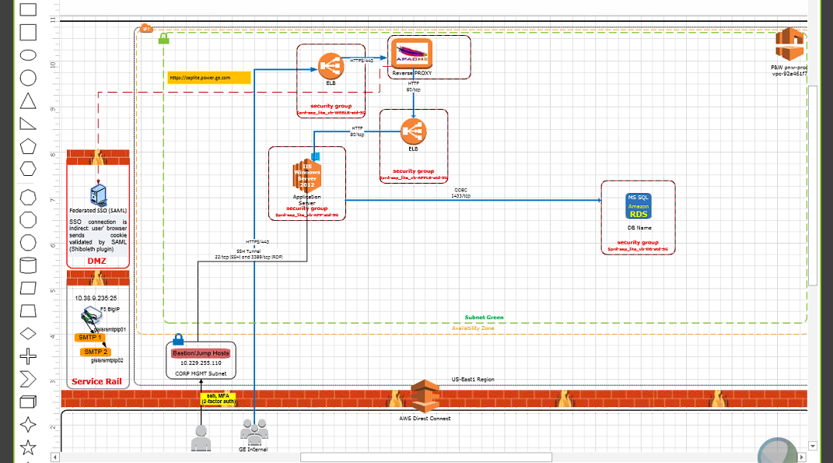

1. Creating an EC2 Windows Instance in Amazon VPC using CF Gen
2. Setting up Apache Contexts
3. Creating a RDS Instance in Amazon VPC using CF Gen
4. Setting DNS using Jenkins
5. Add the Instances to the ELB
6. Add the 3.x Security Group (sg-b58c1ad0) to the ELB (add it in CF Gen while building or ad it from the AWS Console)
7. Go to the Web Apache in GIT (ssl.config and remove the rewrite commands)
8. Set up OIDC

According to Shaun, a separate OIDC request does not need to be submitted as this is created via the CFGen build; the OIDC.conf file shows the configuration, for example: [**applicationConfig**](https://github.build.ge.com/pw-web/applicationConfig)/[clearorbit](https://github.build.ge.com/pw-web/applicationConfig/tree/master/clearorbit)/[clearorbit_qa](https://github.build.ge.com/pw-web/applicationConfig/tree/master/clearorbit/clearorbit_qa)/[ws](https://github.build.ge.com/pw-web/applicationConfig/tree/master/clearorbit/clearorbit_qa/ws)/[pw_web_apache2_4](https://github.build.ge.com/pw-web/applicationConfig/tree/master/clearorbit/clearorbit_qa/ws/pw_web_apache2_4)/**oidc.conf**

He said he normally always selects PROD for SSO unless STG SSO are specifically requested

This is the link to check the client details: <http://3.8.86.55/clientCheck/index.php>

For example, for clearorbit:

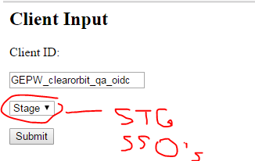

Client Output

This client was not made in the portal.

Details:

Array

(

[bypassApprovalPage] => true

[clientId] => GEPW_clearorbit_qa_oidc

[description] => this is from automation.

[forceSecretChange] => false

[grantAccessSessionRevocationApi] => false

[grantTypes] => Array

(

[0] => refresh_token

[1] => authorization_code

)

[lastModified] => 2017-06-05T08:08:49.539-04:00

[name] => PW_Web_Team

[persistentGrantExpirationTime] => 0

[persistentGrantExpirationTimeUnit] => d

[persistentGrantExpirationType] => SERVER_DEFAULT

[pingAccessLogoutCapable] => false

[redirectUris] => https://qa-suppliercollaboration.power.ge.com/redirect_uri

[restrictScopes] => true

[restrictedScopes] => Array

(

[0] => profile

[1] => openid

)

)

1. using OIDC Self Service (<https://oidcapi.corporate.ge.com/#/submit>)

“How OIDC Self Service Works”: (<https://ge.app.box.com/s/rh20kwvmuk2iwf9a4vnkp6lcnqi9owur>)

OIDC Self-Service Dashboard: <https://oidcapi.corporate.ge.com/dashboard.php>

Update or Delete OIDC Clients: <https://oidcapi.corporate.ge.com/#/review>

OIDC – Shilpa Patel

2-Legged – Doesn’t prompt user for SSO

3-Legged – Prompts user for SSO

1. Accessing the server through Bastion using Remote Desktop Connection

**Bastion NetGroups:**

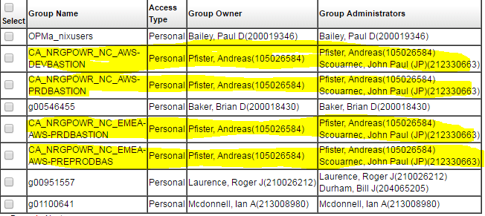

**HIGH RISK VPC**

**Shaun – 6/30/17**

If you will need console access to the high risk VPC here are the details for the role. This just got released so limiting the who we are suggesting to get access, until we can ensure we have what we need.

@GE AWS_pwr-sharedhr_hq/bu-pw-cldarch-fed_464798753408

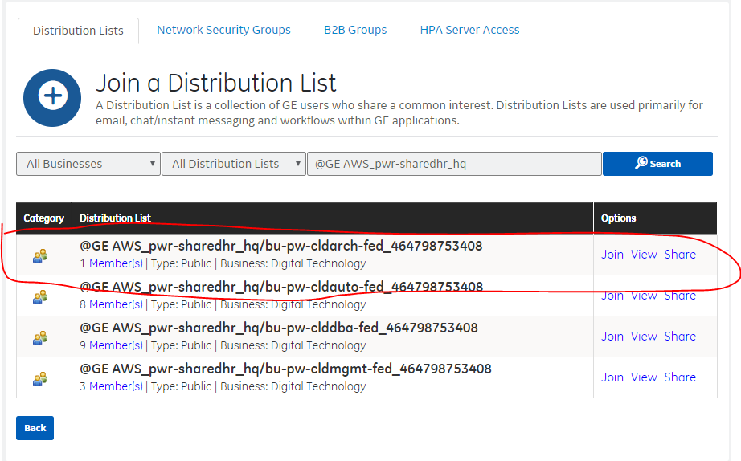

**Confluence – Server Access in AWS**

<https://devcloud.swcoe.ge.com/devspace/display/SGYXB/Server+Access+In+AWS>

Any member of the development team who will need admin access to the AWS application server needs to request access to the Bastion jump boxes.  The access request is in IDM.

Go to the IDM Nix Admin Account and Group Membership request page (or alternatively: go to <http://oneidm.ge.com> > Request Access > IT SECURITY - ADMINISTRATIVE SYSTEMS > Nix Admin Account and Group Membership - GE)

Note there is a Bastion for non-PROD and another for PROD:

* Pre Prod US: CA_NRGPOWR_NC_AWS-DEVBASTION
* ProdUS: CA_NRGPOWR_NC_AWS-PRDBASTION

Refer to Section 3 of the [AWS Access Guide](http://libraries.ge.com/download?fileid=539216790101&entity_id=44760807101&sid=101) for additional details to request access to the Bastion jump box and from there to the application instance.

**AD Network Security Group**

For Windows servers in AWS, AD Network Security Groups are created in OneIDM: <https://oneidm.ge.com/faces/modules/nw_groups/nw_groups_create.xhtml>

For the ***Name*** field, I suggest something like: **docwareus_stg**

The ***Full Display Name*** field will populate automatically.

Send me the ***Full Display Name*** created so I can add it to the EC2 server when it’s created.

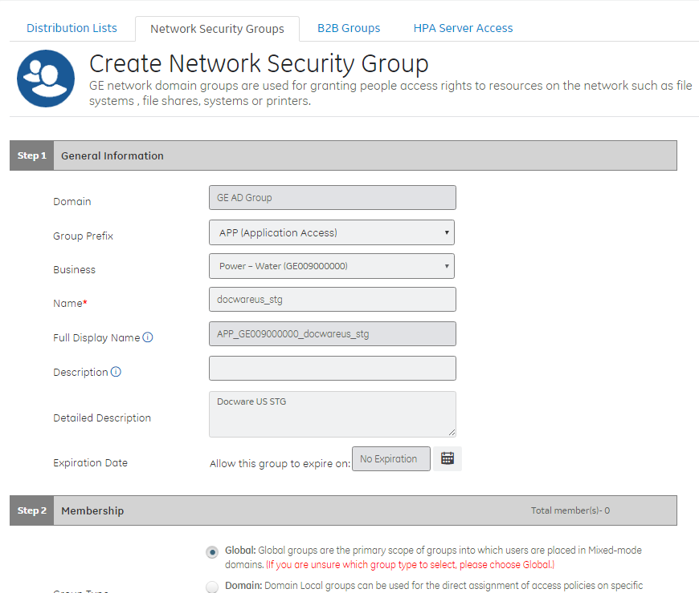

**Prerequisites:**

1. Project team needs to register application in **Application Repository** and obtain UAI; ideally they should enter the BUC/ADN billing information
2. If it does not exist, project team needs to create application CI and associated instance CIs in ServiceNow. CI attributes need to be correct, especially Criticality Tier, Critical System, EC, and Data Classification.
3. What is the Cloud Risk level? [High, Med, Low]
4. Review the Public Cloud Security site -https://devcloud.swcoe.ge.com/devspace/display/YFBSU/Public+Cloud+Security
5. Is the application externally facing?
6. Does the application include a separate mobile component?
7. For Linux or CentOS apps, the business team needs to create NetGroups for each environment (DEV, QA, STG, PROD) in IDM – AD netgroups are created in IDM (<https://oneidm.ge.com/faces/modules/nw_groups/nw_groups_create.xhtml>); Unix netgroups are created using this workflow: <http://supportcentral.ge.com/ProcessMaps/form_new_request.asp?prod_id=14927&form_id=573365&node_id=1927082&map_id=&reference_id=&reference_type>=
8. For Windows apps, the business team needs to create an AD Group beforehand in IDM
9. Project team members who need admin access to the AWS app server will need to request access to the Bastion jump boxes in IDM
10. Obtain Power VM Build Exception approval: <http://forms.ge.com/create/198748>
11. Update Cloud status and Cloud attributes in planET: <http://planet.pw.ge.com/planet/Home.aspx?gpstate=none,it_0>
12. Review ‘As Is’ infrastructure diagram and information in SN
13. Identify database Instance and Schema names
14. What is the as-is tech stack, e.g. Jboss, Tomcat, DB?
15. What is the target to-be tech stack and what upgrade challenges need to be addressed?
16. Detail the as-is and to-be application integrations and technologies
17. Has the application already been migrated to OIDC RP?
18. How does the application manage users, groups and roles, including B2B users? [IDM, LDAP, SAM]
19. Complete the AWS Application Profile .xlsx (or the AWS Application Profile Passport ): <https://ge.box.com/s/6o9sj47ntxk7jh8zvkhwf2ulccmoo3lw>, especially the source code repository information in the Auto Deployment tab and the integrations in the High Level Integrations tab.
20. What cloud environments are needed, PROD, nonPROD?
21. What is the target VPC?
22. Will the cloud environment be SZ, MZ, auto-scaling?
23. What are the target deployment and Go Live dates for nonPROD and PROD?
24. What are the desired AWS URLs (internal: pw.ge.com (or is it power.ge.com?); external: gepower.com)?

Internal should be power.ge.com; here’s the DNS request in Jenkins

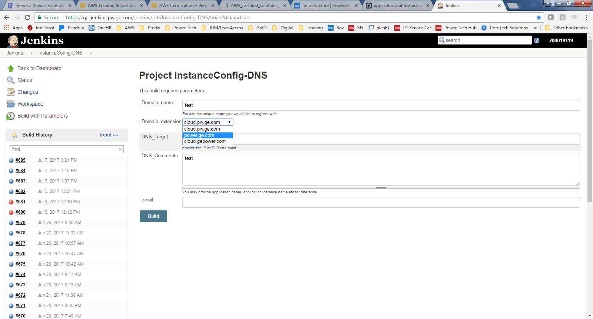

1. What is the app context?
2. What ports does the app listen on (between Apache and app server)?
3. Business team admins need to request access to nonPROD and PROD Bastions
4. Create AWS infrastructure Diagram (Visio)
5. Provide AWS cost estimate using:
   1. AWS Simple Monthly Calculator: <https://calculator.s3.amazonaws.com/index.html>
   2. AWS Complete Cost Estimate spreadsheet: <https://ge.ent.box.com/file/94755444109>
6. SSO for non-PROD – STG or PROD?

**Creating a ELB in Amazon VPC using CF Generator (add elbs as per the design, eg: HA requirement))**

1. Please login to the following link to access the CF generator: <https://dev.cloud.pw.ge.com/portal/cfgen>
2. Enter appName (APP CI name), appInstance (it should match the app instance in CMDB,), AssetID (enter CMDB unique ID here) and UAI. Do a Quick CI search in Service Now and look for the details of the application to find UAI information. All this information can be gathered from <https://applications.ge.com/#/>

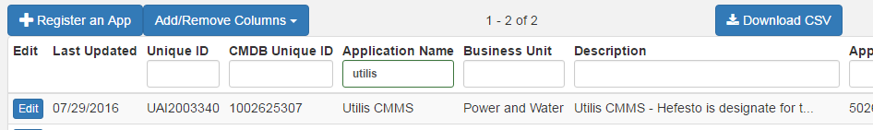

Add all the info to CF Gen

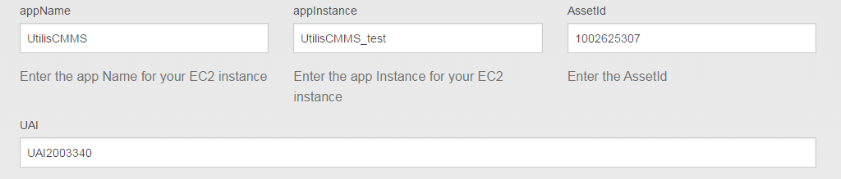

1. Click on Add Server. To build an ELB, select ELB as the resource in the server option.
2. Choose the ELB Configuration (**select the region here**) as per the environment requirement of the build.

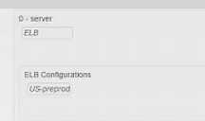

1. Choose the right Subnet as per the project requirement. (list of subnets: <https://devcloud.swcoe.ge.com/devspace/display/LDLUN/List+of+subnets>)
2. Enter the instance for the elb, you can create one (ex: cmms-web-elb) – Leave this blank, add this only if youhave an instance that you want connected to this resource.

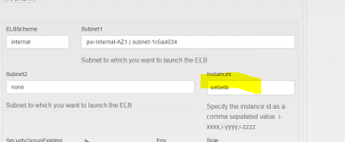

1. Leave the security group blank here and let the template create a security group for the elb. No security group is needed for the first elb because we want all traffic to be able to go in and out of this elb. (SGs to be implemented from EC2 instance onwards to allow traffic from this elb and so on, if you have other elbs, they will need SG details)

Add the 3.x Security Group (sg-b58c1ad0) for ports 80 and 443 – need to confirm

Note: while building a STG ELB (for granite-onthego), the create failed because **sg-b58c1ad0 doesn’t exist**. Is this 3.x SG just for non-PROD?

pgp-lessons-learned-prod – App server was not communicating with web server, so Port 80 configured on App server sg-73df460e to enable listener from the Web instance:

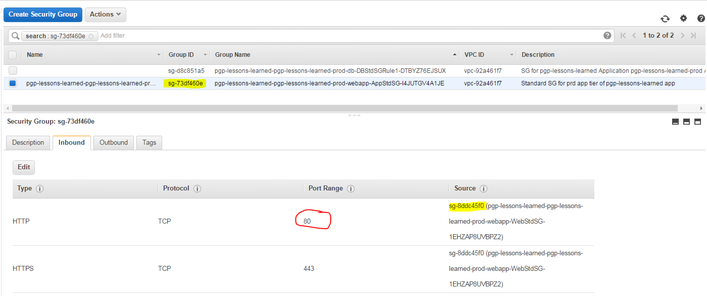

1. Select the environment for the build as per requirement.

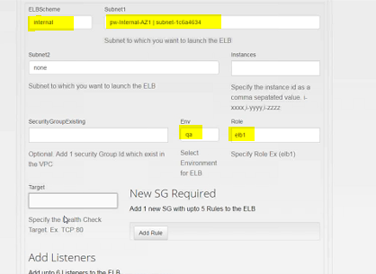

1. Specify the role here. Create one. (ex: elb)
2. Specify the Target here as TCP 80 as the port so that traffic can be received at this port.

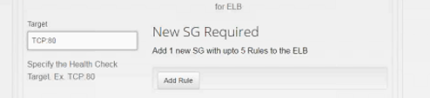

1. Add the listeners now and add the following details for all the ports:

For example:

* 1. Click on Add rule
  2. LBProtocol : TCP
  3. LBPort: 80
  4. InstancePort:80
  5. Click on Add rule:
  6. LBProtocol : TCP
  7. LBPort: 443
  8. InstanceProtocol:TCP
  9. InstancePort: 443

1. In case of HTTPS, CERT details?? certificates.ge.com , depends on externally/internally facing, place before the elb??

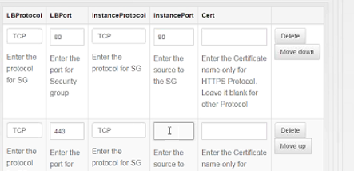

1. Submit the build request. You will receive a pop-up. Click on OK
2. To check the progress of the build, go to AWS console, select the environment you built in, and click on CloudFormation and you will be able to see the elb cloudformation stack is in progress. (create_in_progress). The naming convention followed is appname-appInstance-role (ex: UtilisCMMS-qa-utiliscmms-web-elb)

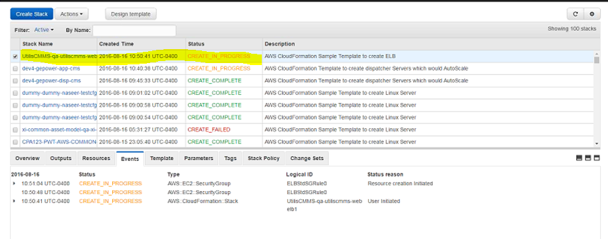

1. Click on the stack name for the elb and open the Resources tab to get the physical ID for the security group created for this elb.

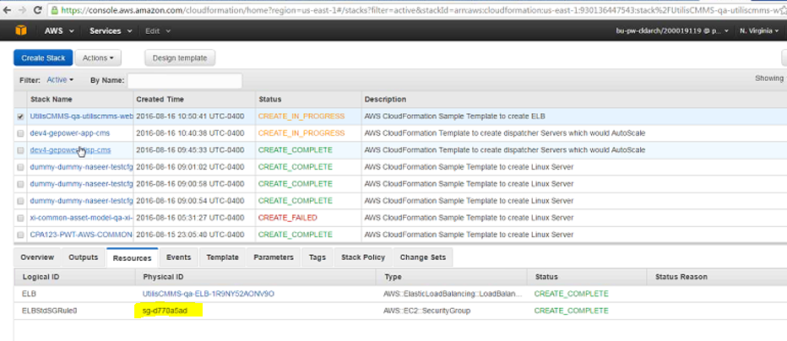

1. These configurations will get saved as pfile in the following location and you will also receive a email with the location details: <https://github.build.ge.com/pw-web/CloudFormationPfiles/tree/master/parameters>

Note: If CloudFormation indicates the build failed and was rolled back, the stack must be deleted before another request with the same attributes can be submitted.

|  |  |
| --- | --- |
| Tadepalli, Venu (GE Power) |  |
| pgp-lessons-learned-pgp-lessons-learned-qa-web | 4:14 PM |
| yes since it is in rolled back state AWS won't let you update | 4:14 PM |
| delete the stack in was console and try | 4:14 PM |
|  | |
| Taylor III, Donald (GE Power) |  |
| oh, ok | 4:15 PM |
| just deleted stack | 4:15 PM |
| should i submit the cfgen request again or is it already in the queue? | 4:16 PM |
|  | |
| Tadepalli, Venu (GE Power) |  |
| no please make a small commit | 4:23 PM |
|  | |
| Taylor III, Donald (GE Power) |  |
| where?  in the pfile? | 4:24 PM |
|  | |
| Tadepalli, Venu (GE Power) |  |
| in git hub | 4:24 PM |
|  | |
| Taylor III, Donald (GE Power) |  |
| ok | 4:24 PM |
|  | |
| Tadepalli, Venu (GE Power) |  |
| parameters/pgp-lessons-learned/pgp-lessons-learned-qa/web/pfile.json | 4:25 PM |
| https://github.build.ge.com/pw-web/CloudFormationPfiles | 4:25 PM |
|  | |
| Taylor III, Donald (GE Power) |  |
| ok | 4:25 PM |
| ok, just did a commit, #93 | 4:28 PM |
|  | |
| Tadepalli, Venu (GE Power) |  |
| merged | 4:29 PM |
|  | |
| Taylor III, Donald (GE Power) |  |
| thanks, so i should see it in a minute or so in cloudformation? | 4:30 PM |
| i see it now, thanks |  |

**Creating a EC2 Linux Instance (Apache) in Amazon VPC using CF Generator**

1. Please login to the following link to access the CF generator: <https://dev.cloud.pw.ge.com/portal/cfgen>
2. Enter all the aforementioned details to start the build for Apache. (Or click on Delete last server to clear the last server configuration)
3. Click on Add server. Select EC2 Linux for the AWS resource.
4. Select the Server configuration (**select the region here**) as per the build requirement.

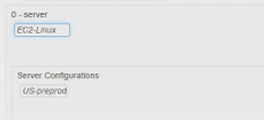

1. Default selection for Server Type is centOS7.
2. Select the subnet for the instance and the instance type from the project requirement from the list of subnets.
3. Select the Instance type.
4. Enter the security group info if you already have a security group, else leave it blank.
5. Enter the InstanceProfile if it exists (optional). An instance profile is a pre-negotiated authentication system with a resource in AWS. Eg: S3 bucket (Shaun to provide more information and uses cases)
6. Select the applicable Environment for this build.
7. Enter the role for the EC2 Instance
8. Enter the RoleType (ex: web in this case)

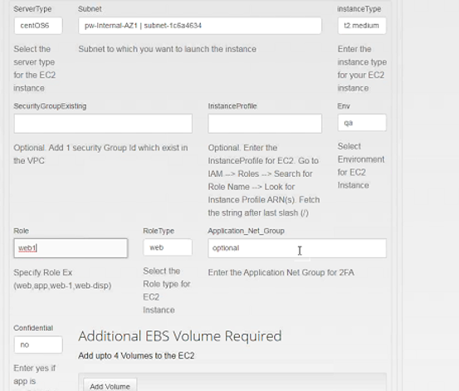

1. Enter the application’s confidential status.
2. Additional EBS not added for this Apache layer
3. Click on Add rule to add security group
4. s here.
5. Enter the Security group info here. For example; to allow traffic from the elb we created above, select the SG from the resources Tab (from the AWS Console) for the elb and add it here. Enter the port details here (ex: 80/443) and the Source SG in the both the rows, the Source SG will be the same. One SG with 5 rules can be entered for one instance.

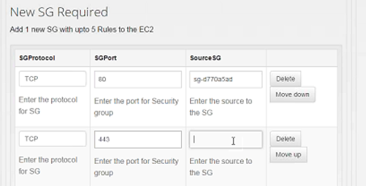

1. Click on Add Service
2. Select Apache for this build
3. Select the authentication mode. (openID/SAML)
4. Enter the FQDN details here. (environment-applicationname-power.ge.com), only for stage, qa and dev, no environment detail added in FQDN incase of Prod.
5. Select if the instance is externally facing or not.

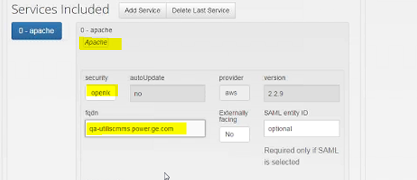

1. Click on Add Mappings to set up Apache contexts, this step is required to setup Apache as a service. (you will need to setup the context in Github as well with the application server instance.)

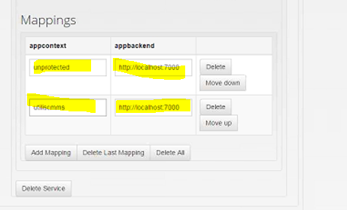

1. Click on submit to start the build. Once you submit the build request you will get a popup saying “Committed to GIT success. Click OK
2. Go to AWS Console, CloudFormation to see the stack. It will be in create_in_progress state.
3. You can go to the Resource tab for the stack to the security groups created. Use this as security group to allow traffic from this EC2 instance to the application server built next.

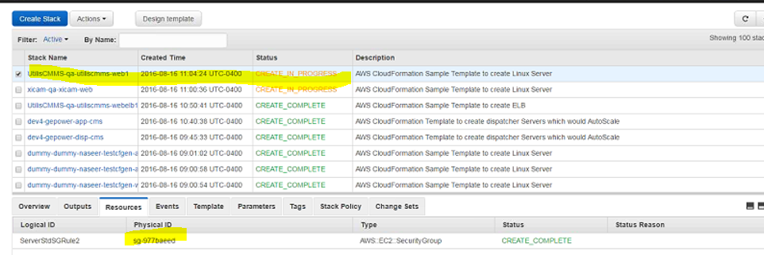

**Creating a EC2 Windows Instance in Amazon VPC using CF Generator**

1. Please login to the following link to access the CF generator: <https://dev.cloud.pw.ge.com/portal/cfgen>
2. Enter all the aforementioned details to build for Application Server. (or click on delete to remove the last build details and add a new server here or refresh the cf gen tool because it times out)
3. Enter the aforementioned details and click on add a server
4. Select EC2 Windows for your application server.
5. Select the Server Configuration **(select the region here)** **.** Ensure it is the same region as all your prior ELB/Apache regions.

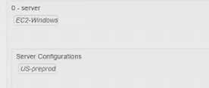

1. Select the instance type
2. Enter the existing SG details if created from beforehand. Or else leave it blank and it will create one.(how can I find an existing Security Group??) (AWS Console—EC2—SG)
3. Enter the environment for the app server
4. Enter the Role of the server (ex: app)
5. Enter the RoleType (ex: app)
6. Enter the confidentiality status of the application

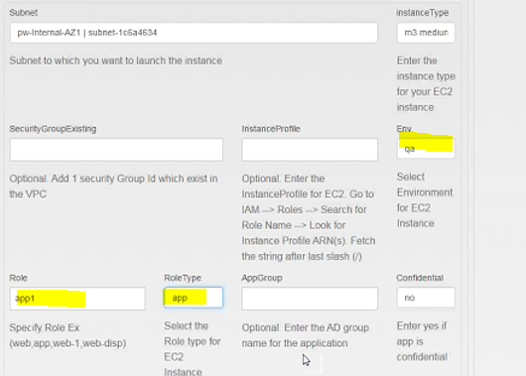

1. Create an AD group to add here, by going to the following link: <http://kb.ds.ge.com/ad-processes/cloud-ad/>. (You will create the AD group in IDM, this link enumerates the steps to create an AD group). Add yourself and the application owner to the AD group, remove yourself later from this AD group. You will receive an email from IDM confirming the creation of the AD Group:

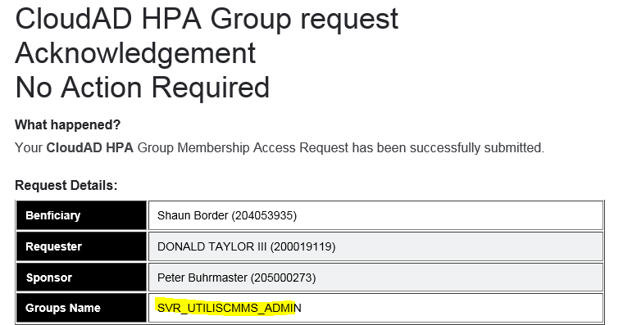

Actually in IDM the steps are:

HPA Server Access --> Group Creation --> Create a Server Admin Group

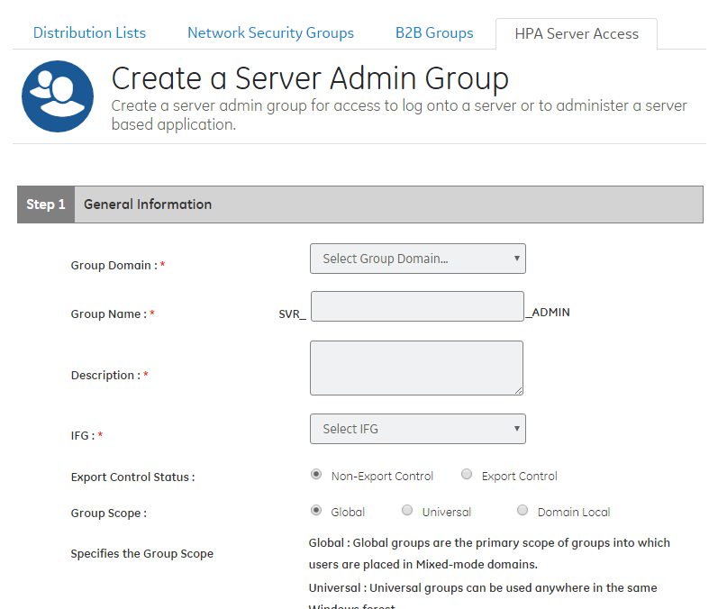

Add it to the CF Gen like so:

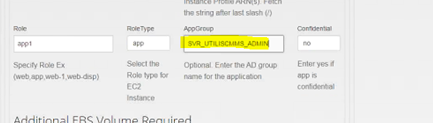

Example from DP-Spatsl project:

*The* ***STG*** *environment of “****DP-Spatsl****” app is ready for use. The updated application migration profile has been uploaded → https://ge.app.box.com/files/0/f/8591638921/dp-spatsl2.0-ser   PFA.*

*Refer to the steps provided in* [*AWS Access Guide*](http://libraries.ge.com/download?fileid=539216790101&entity_id=44760807101&sid=101) *to request access to Bastion. The AD group* ***SVR_GE009000000_dp_spatsl2_0_ser_Admin*** *has been added to the server. Follow the instructions @* [*http://kb.ds.ge.com/i-need/access-to-a-group/groups-cloudad-domain-2/hpa-groups/2/*](http://kb.ds.ge.com/i-need/access-to-a-group/groups-cloudad-domain-2/hpa-groups/2/) *to request for membership to this AD group.*

**NET GROUP CREATION – for Unix/Linux**

Creating a group

Each application should have 2 groups created at minimum for that application (Prod and Non-Prod). Group creation is currently a manual process and can take up to 3 business days. Currently it involves completing a workflow and then waiting for confirmation that the group was created. Please follow the following instructions to fill out this workflow:

**Application Group Owner's SSO:**This must be a GE Employee and can only be one person. This person will be the only one who can delegate and create Group Managers.

**Application Group Manager's SSO:**This can be one or more people who have the capacity to add/remove users

**Application Name Information:** Please use this format - PWR_{APP_NAME} . Example - "PWR_CLOUD_EA_ADMINS"

**Application Description:** The application UAI is all that is necessary here.

The link to start the process is here: <http://supportcentral.ge.com/ProcessMaps/LaunchProcess.asp?prod_id=14927&proc_id=1927081>.

1. Add the additional EBS Volume here as per project requirement (maybe mentioned in the infrastructure diagram) Note: IAM access is only for Cloud team, Vinnie and Bernie will be able to provide.

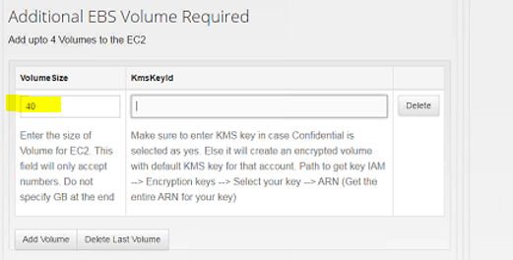

1. Add the SG details here to allow traffic to this server. (ex: enter the SG detail from the Apache you built before in this section to allow traffic from the server)

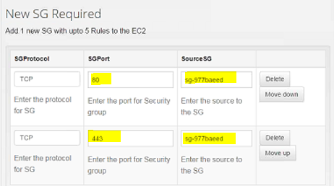

1. Submit to start the build.
2. You will get 2 pop-ups click OK for both.
3. Go to AWS Console, CloudFormation to check the stack for the EC2 instance.

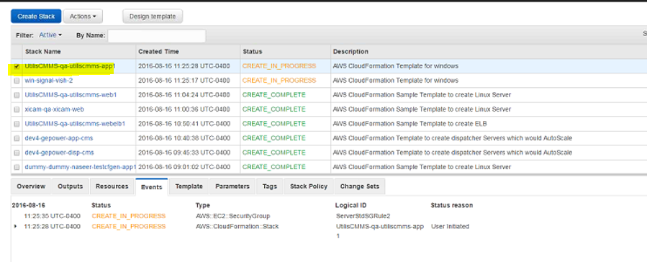

**Setting up Apache Contexts**

1. Need to wait for 10 minutes before next step
2. Setting up context: Go to the AWS Console home, go to EC2, go to Instance, search for the app instance we just built, go to Descriptions, select the Private IPs.

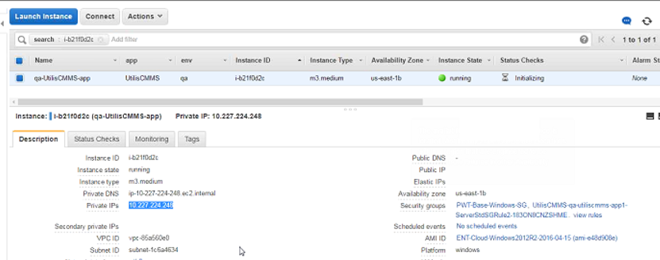

1. This context needs to be edited in the SSL.config file in github
2. Go to <https://github.build.ge.com/pw-web/applicationConfig/>
3. Select the application instance and go to pw_web_apache folder
4. Click on the SSl.conf file to make the change

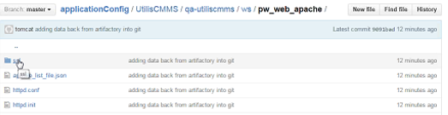

1. Change the following localhost information: (You need be in edit mode to make these changes)

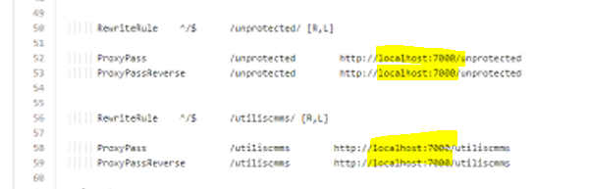

1. Add the Private IPs copied from the AWS Console: Change for all the 4 iterations (**please also add the port at which the application can listen, eg: 7000 or 80)**

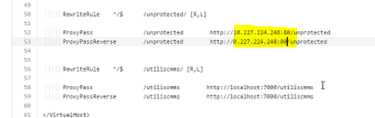

1. Click on Propose File Change
2. Finally click on Create Pull request
3. Application Configuration merges automatically.

The connectivity from web to app should be on port 80 (according to Muffi). Change the appConfig file in github to 80 instead of 7000; then test the URL: qa-power-engineering-drupal.power.ge.com/index.html

applicationConfig/power-engineering-drupal/power-engineering-drupal-qa/ws/pw_web_apache2_4/ssl.conf

ProxyPass /power-engineering-drupal http://10.227.230.10:80/power-engineering-drupal

ProxyPassReverse /power-engineering-drupal http://10.227.230.10:80/power-engineering-drupal

RewriteRule ^/$ /unprotected/ [R,L]

ProxyPass /unprotected http://10.227.230.10:7000/unprotected

ProxyPassReverse /unprotected <http://10.227.230.10:7000/unprotected>

We just tested our access to the QA environment for MyQMS, we were able to access with no problems, but now we will need assistance to install php,

we tried “sudo yum install… ” but got an error that says “account is not allowed to execute as root”, what do we need to do here? - Jorge Vidrio

Go to [**applicationConfig**](https://github.build.ge.com/pw-web/applicationConfig)/[pex](https://github.build.ge.com/pw-web/applicationConfig/tree/master/pex)/[pex-qa](https://github.build.ge.com/pw-web/applicationConfig/tree/master/pex/pex-qa)/[app](https://github.build.ge.com/pw-web/applicationConfig/tree/master/pex/pex-qa/app)/**appConfig.json**

Expanded the permission level to "ALL" for the NetGroup CA_AWSENTC_NC_PWR_PEX_QA:

{

"CA_AWSENTC_NC_PWR_PEX_QA": [

"ALL"

]

}

**DEBUGGING WEB ISSUES**

|  |  |
| --- | --- |
| Taylor III, Donald (GE Power) |  |
| me neither, i've got one going now with Naseer and Raju | 4:22 PM |
|  | |
| Ojha, Ipsita (GE Power) |  |
| Raju is good, he helps out a lot , also in IST timing Swaroop Kishan | 4:23 PM |
| for all web issue |  |

**DEBUGGING OIDC REDIRECT ERROR**

From legacy GIS DoD to AWS instance; <http://gis04576.devcloud.ge.com/app/MyQMS/> redirects to <https://myqms.power.ge.com> but results in an OIDC error. OIDC was not able to validate the token passed from the legacy instance to the AWS instance.

**Fix:**

[**applicationConfig**](https://github.build.ge.com/pw-web/applicationConfig)/[quality-docs](https://github.build.ge.com/pw-web/applicationConfig/tree/master/quality-docs)/[quality-docs-prod](https://github.build.ge.com/pw-web/applicationConfig/tree/master/quality-docs/quality-docs-prod)/[ws](https://github.build.ge.com/pw-web/applicationConfig/tree/master/quality-docs/quality-docs-prod/ws)/[pw_web_apache2_4](https://github.build.ge.com/pw-web/applicationConfig/tree/master/quality-docs/quality-docs-prod/ws/pw_web_apache2_4)/**oidc.conf**

# Path which should be protected by this module. Default is "/" (everything.)

# Attribute based authorization rules can be added. for more info: sc.ge.com/*oidc

<Location /unprotected/>

Satisfy Any

Allow from all

</Location>

<Location /quality-docs>

Satisfy Any

Allow from all

</Location>

[**applicationConfig**](https://github.build.ge.com/pw-web/applicationConfig)/[pgp-lessons-learned](https://github.build.ge.com/pw-web/applicationConfig/tree/master/pgp-lessons-learned)/[pgp-lessons-learned-prod](https://github.build.ge.com/pw-web/applicationConfig/tree/master/pgp-lessons-learned/pgp-lessons-learned-prod)/[ws](https://github.build.ge.com/pw-web/applicationConfig/tree/master/pgp-lessons-learned/pgp-lessons-learned-prod/ws)/[pw_web_apache2_4](https://github.build.ge.com/pw-web/applicationConfig/tree/master/pgp-lessons-learned/pgp-lessons-learned-prod/ws/pw_web_apache2_4)/**oidc.conf**

# Path which should be protected by this module. Default is "/" (everything.)

# Attribute based authorization rules can be added. for more info: sc.ge.com/*oidc

<Location /unprotected/>

Satisfy Any

Allow from all

</Location>

<Location />

AuthType openid-connect

Require valid-user

</Location>

<Location /server-status>

AuthType None

Require all granted

</Location>

**Creating a RDS Instance in Amazon VPC using CF Generator**

1. Please login to the following link to access the CF generator: <https://dev.cloud.pw.ge.com/portal/cfgen>
2. Enter all the aforementioned details and start the build for DB Server. (or click on delete to remove the last build details and add a new server here)
3. Click on add a server
4. Select RDS for the AWS Resources
5. Select RDS Configuration and the type of DB required (ex: US-pre-prod, ex: MicrosoftSQL Server)

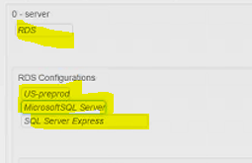

1. Select the RDSInstanceClass. (details of what should be selected/guidelines for RDSInstance class)
2. Enter the Allocated Storage
3. Select the environment for this particular build.

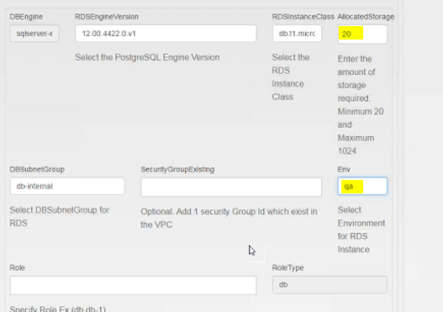

1. Enter the role of the server. (ex: db)

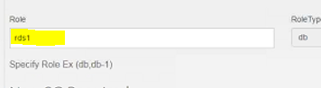

1. Click on Add Rule to add the Security Group. Add the SGPort Value (1433, the port for SQL Server) and the Source SG , which in this case is the SG ID for the Windows application server built before this.

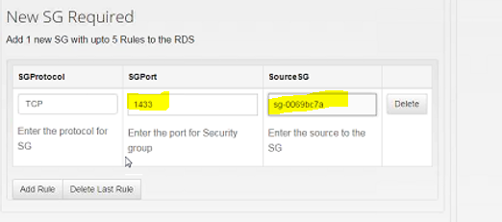

1. Submit the build request. Click OK for both the pop-ups.
2. Go to the AWS Console, CloudFormation to check the stack build in progress.

|  |  |
| --- | --- |
|  |  |
| Monday, October 10, 2016 | |
| Taylor III, Donald (GE Power) |  |
| hi | 2:07 PM |
|  | |
| Millard, Brian (GE Power) |  |
| hi Don | 2:08 PM |
|  | |
| Taylor III, Donald (GE Power) |  |
| Jags is pinging me about his database connection issue | 2:08 PM |
| Did you see my email from last night about using the other AWS app to try some tests? | 2:08 PM |
|  | |
| Millard, Brian (GE Power) |  |
| I did see it, I haven't been able to do anything on it today | 2:09 PM |
|  | |
| Taylor III, Donald (GE Power) |  |
| do you think you'll be able to do today?  i would like to give him an idea of timing | 2:09 PM |
|  | |
| Millard, Brian (GE Power) |  |
| I'm pretty swamped today; what exactly are they looking for us to do? | 2:10 PM |
|  | |
| Taylor III, Donald (GE Power) |  |
| he wants to try to connect to the power-engineering-drupal db from the safety-products EC2 app instance | 2:11 PM |
| and maybe try to connect to the safety-products db from the pwr-engr-drupal app instance | 2:11 PM |
|  | |
| Millard, Brian (GE Power) |  |
| as long as they have the connection string (endpoint) info and the necessary passwords, they should be able to do this. | 2:11 PM |
|  | |
| Taylor III, Donald (GE Power) |  |
| ok, that's cool, let me tell him that | 2:12 PM |

Also need to provide the app instance Security Group (sg-xxxxxx) to the database.

Hi guys.  The SG mods have been made to both databases, they should now have the same SG’s.  Please see below for clarification. - Brian

**pnmyrolq7896power-engineering-drupal.cdgt1df1uu9r.us-east-1.rds.amazonaws.com:3306**

|  |  |
| --- | --- |
| **Security Groups**List of VPC Security Groups associated with this DB Instance. | [PWT-allow-datamover-RDS-SG (sg-cb8f78af)](https://console.aws.amazon.com/ec2/v2/home?region=us-east-1#SecurityGroups:search=sg-cb8f78af)  ( active )  [power-engineering-drupal-power-engineering-drupal-qa-db1-DBStdSGRule1-XXZHGAJXU0PC (sg-2b681e51)](https://console.aws.amazon.com/ec2/v2/home?region=us-east-1#SecurityGroups:search=sg-2b681e51)  ( active )  [PWT-base-RDS-SG (sg-9f500dfa)](https://console.aws.amazon.com/ec2/v2/home?region=us-east-1#SecurityGroups:search=sg-9f500dfa)  ( active )  [qa-Product-Safety-Drupal-db-std-SG (sg-e7fd3980)](https://console.aws.amazon.com/ec2/v2/home?region=us-east-1#SecurityGroups:search=sg-e7fd3980)  ( active )  [onprem-informatica-SG (sg-0fe98e6a)](https://console.aws.amazon.com/ec2/v2/home?region=us-east-1#SecurityGroups:search=sg-0fe98e6a)  ( active ) |

**pmyrolq19-project-safety-drupal.cdgt1df1uu9r.us-east-1.rds.amazonaws.com:3306**

|  |  |
| --- | --- |
| **Security Groups**List of VPC Security Groups associated with this DB Instance. | [onprem-informatica-SG (sg-0fe98e6a)](https://console.aws.amazon.com/ec2/v2/home?region=us-east-1#SecurityGroups:search=sg-0fe98e6a)  ( active )  [qa-Product-Safety-Drupal-db-std-SG (sg-e7fd3980)](https://console.aws.amazon.com/ec2/v2/home?region=us-east-1#SecurityGroups:search=sg-e7fd3980)  ( active )  [PWT-base-RDS-SG (sg-9f500dfa)](https://console.aws.amazon.com/ec2/v2/home?region=us-east-1#SecurityGroups:search=sg-9f500dfa)  ( active )  [PWT-allow-datamover-RDS-SG (sg-cb8f78af)](https://console.aws.amazon.com/ec2/v2/home?region=us-east-1#SecurityGroups:search=sg-cb8f78af)  ( active )  [power-engineering-drupal-power-engineering-drupal-qa-db1-DBStdSGRule1-XXZHGAJXU0PC (sg-2b681e51)](https://console.aws.amazon.com/ec2/v2/home?region=us-east-1#SecurityGroups:search=sg-2b681e51)  ( active ) |

**Setting DNS using Jenkins**

1. Please visit the following link https://qa-jenkins.pw.ge.com/jenkins/job/InstanceConfig-DNS/
2. Go to InstanceConfig-DNS (Link access in Jenkins)

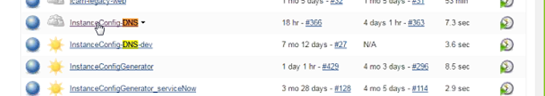

1. Click on build with Parameters
2. Enter the domain name, and the domain extension – Note: Use the OIDCRedirectURI from the oidc.conf file to find the Domain_name and Domain_extension

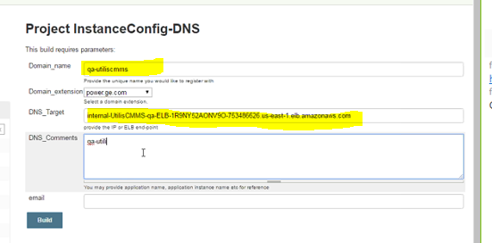

1. Enter the DNS Target (go to AWS Console, the ELB’s DNS Endpoint needs to be entered here)

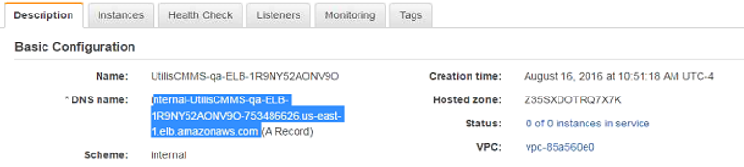

1. Add your email address or else this step will fail.
2. Click on build.
3. Wait for 10 minutes and click on click on last build. Your build will now be complete

Normally PRD DNS names do not have prd- in the name – (from Yasen)

If the app is called app1, the names are

DEV dev-app1.power.ge.com

QA qa-app1.power.ge.com

PRD app1.power.ge.com

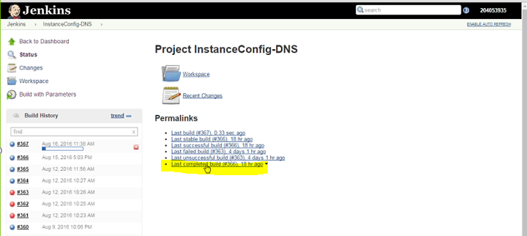

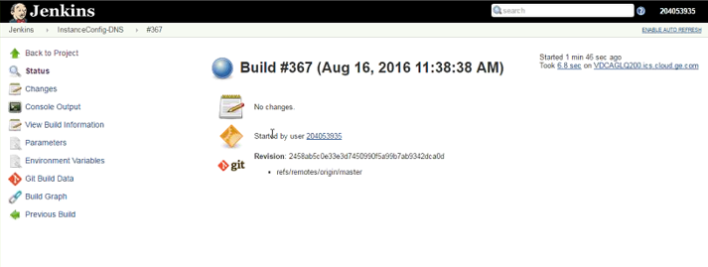

1. Click on Console Output, you can now see the details.

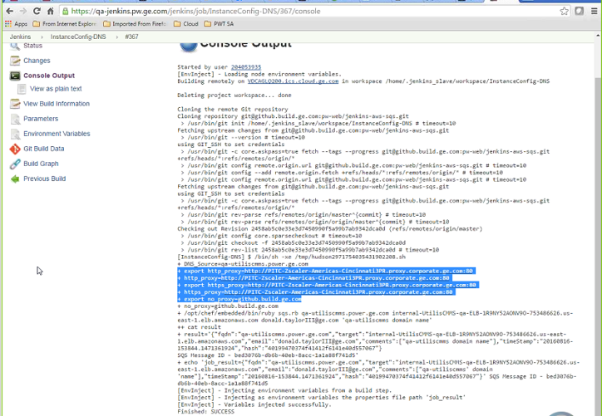

**Add the Web Instances to the ELB**

1. Go to the AWS Console.
2. Go to EC2, click on Load Balancers, search for your ELB, select the instance, right click and select edit instances.
3. It will open a mini-window with all the instances you can add/remove.

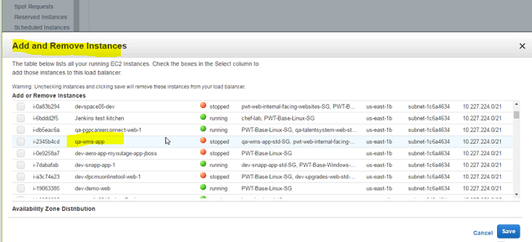

1. Choose the web EC2 instances you have to add, save and exit. Note: Do not add the app instances.
2. The instances tab of the ELB will now show the added instances.

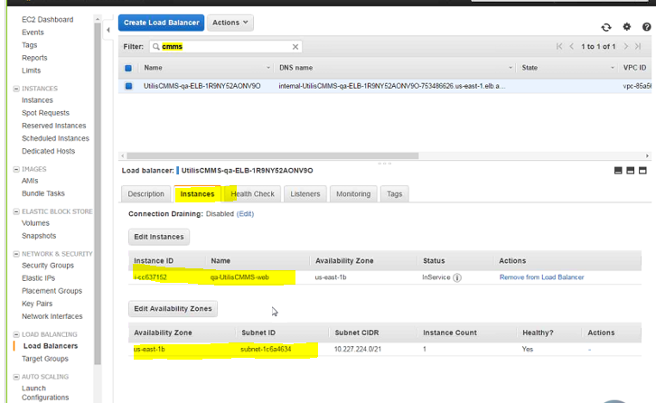

Example from pgpanalytics:

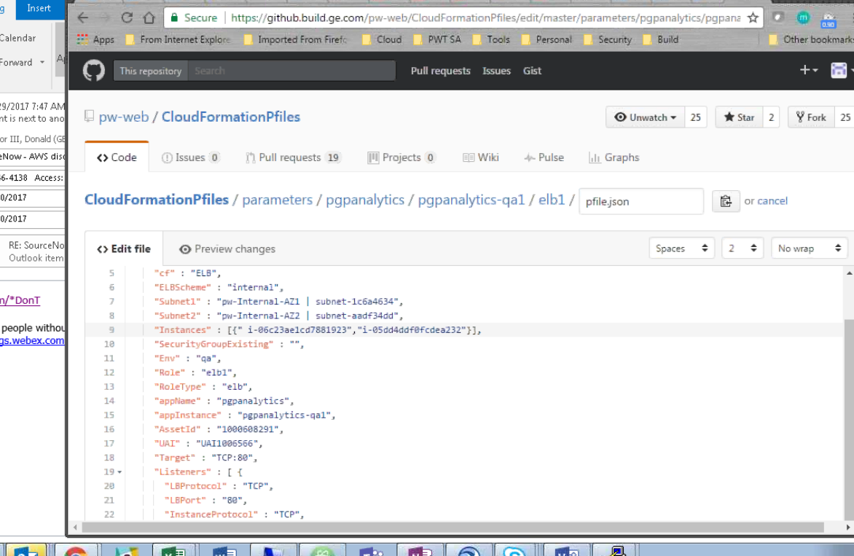

**APP SERVER EBS VOLUMES (CENTOS)**

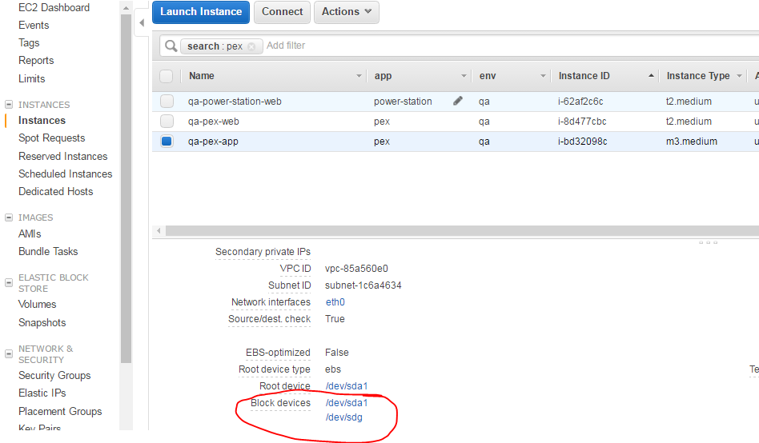

Block device: /dev/sda1

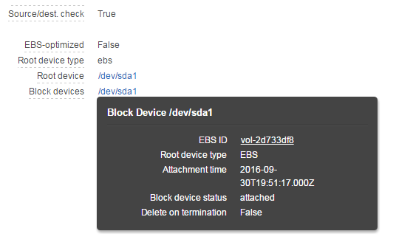

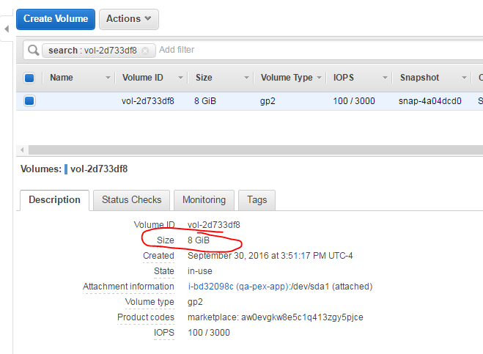

Block device: /dev/sdg

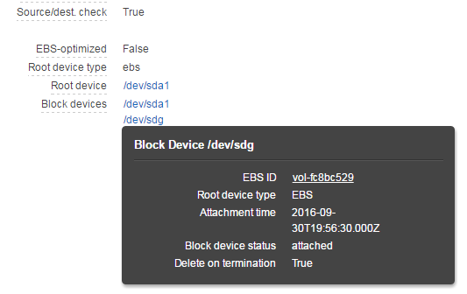

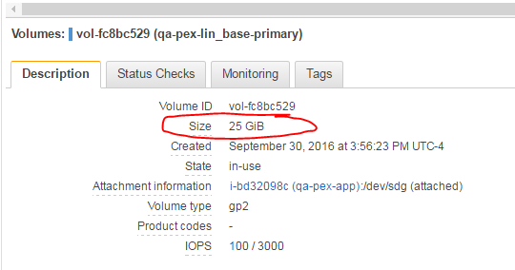

**Accessing the server through Bastion using Remote Desktop Connection**

1. Click on PuTTY.exe
2. It will open a mini window, Click on SSH, then Tunnel
3. Enter IP addresses based on the VPC you need to access (document here)
4. Since RDP needs 3389 to be open to listen, choose a different port as source port.

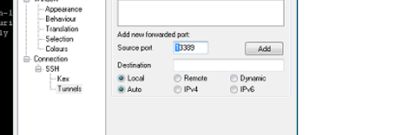

1. Remote Desktop connection will be triggered. Click on connect
2. Enter your credentials to establish connection. (need AD account for access to Windows Server)

Ideally, if we have a host with netgroups in it, we should login with our nix_id and upon logging in, we can switch to appadmin using "sudo su - appadmin"/"sudo su appadmin".  
- Trijit ([trijit.acharyyachowdhury@ge.com](mailto:trijit.acharyyachowdhury@ge.com))

$ sudo su – appadmin

$ hostname 🡪 ip-10-229-241-89 (for ex.)

$ ssh 10.229.241.89 🡪 [lg394859@10.229.241.89’s](mailto:lg394859@10.229.241.89's) password:

$ whoami 🡪 lg394859

$ ssh -i id_rsa [lg394859@10.229.241.89](mailto:lg394859@10.229.241.89)

$ hostname  
ip-10-229-241-89  
$ ls  
$ cd /home  
$ ls  
appadmin  gecloud  lg394859  lg588508  
$ cd gecloud/l  
-ksh: cd: gecloud/l: [Permission denied]  
$ cd appadmin/p  
-ksh: cd: appadmin/p: [Permission denied]  
$ cd lg394859  
$ ls

the steps are:  
1. login with nix_id  
2. switch to appadmin user  
3. do app related things

$ sudo su - appadmin

$ sudo su appadmin

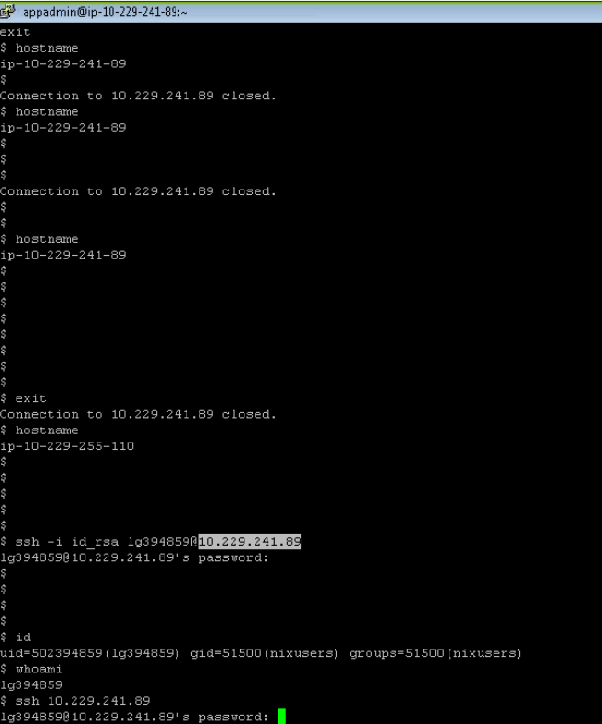

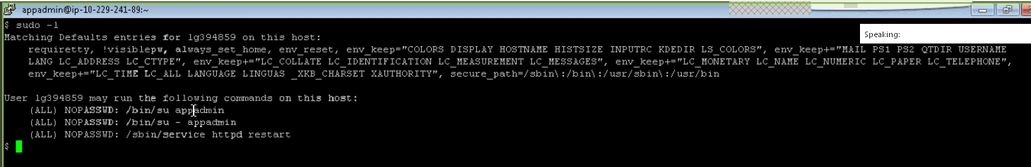

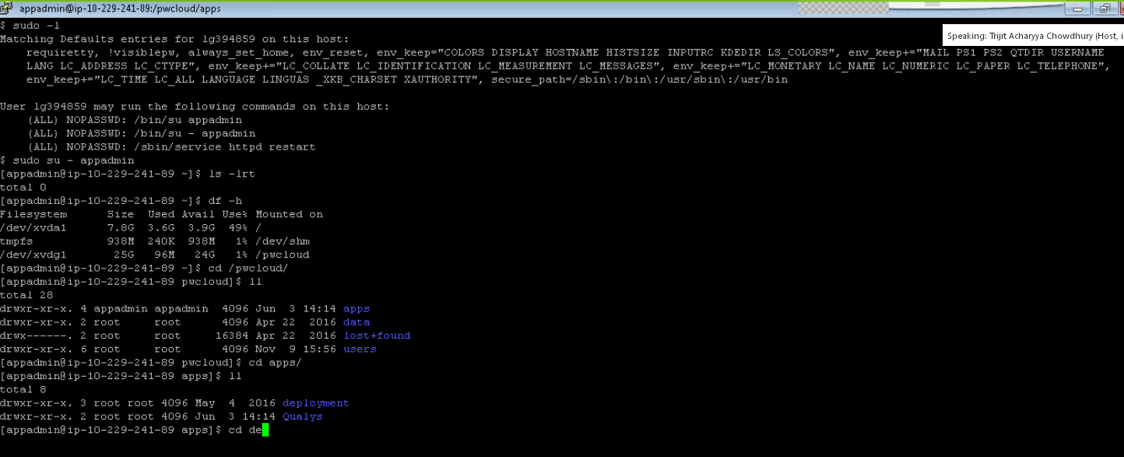

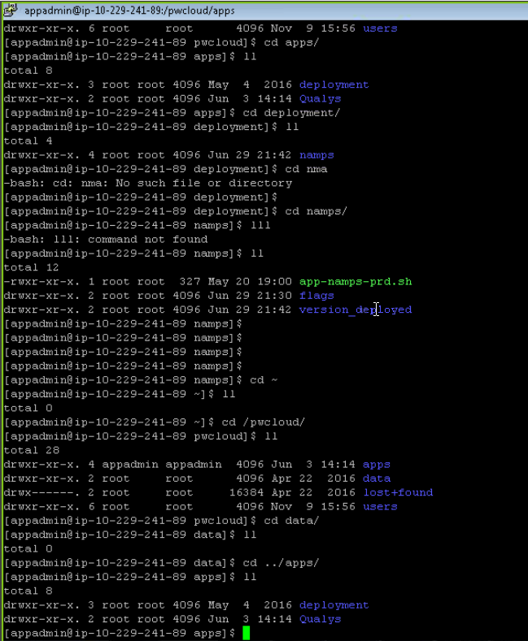

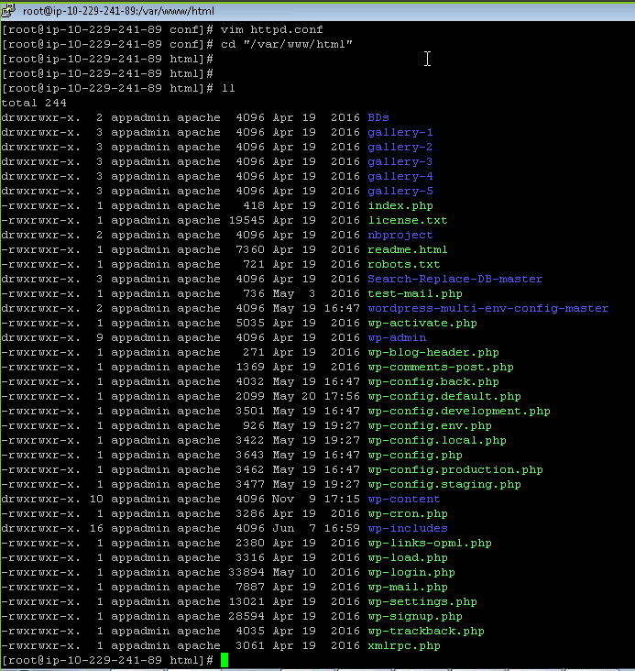

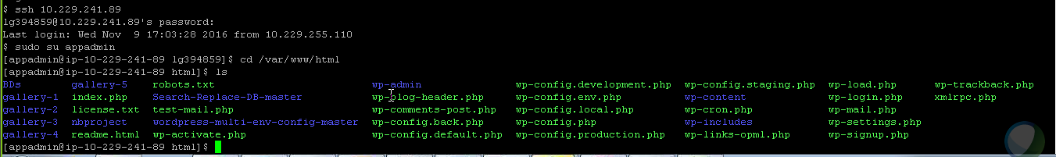

LOGGING INTO WINDOWS EC2 SERVER

|  |  |
| --- | --- |
| Ojha, Ipsita (GE Power) |  |
| Hi Don, I was able to login on a windows server....we can try it sometime when you have time... | 10:46 AM |
|  | |
| Taylor III, Donald (GE Power) |  |
| hi, what did you use? | 10:48 AM |
|  | |
| Ojha, Ipsita (GE Power) |  |
| Login to Bastion Right click on windows and change setting SSH>>Tunnel>> source: 127.0.0.2:13389  Destination: app Ip 10.229.225.229:3389 Add and then Apply Open Remote Desktop Connection (right click and click on Edit) Add app ip in Computer blank and connect: | 10:49 AM |
|  | |
| Taylor III, Donald (GE Power) |  |
| so ssh is enabled by default on the windows servers? | 10:50 AM |
|  | |
| Ojha, Ipsita (GE Power) |  |
| I am not sure, I did not install it though | 10:51 AM |
|  | |
| Taylor III, Donald (GE Power) |  |
| seems like it must be, SSH & RDP | 10:52 AM |
| good to know | 10:52 AM |
|  | |
| Ojha, Ipsita (GE Power) |  |
| maybe yes |  |

**Notes – Logging into a Win EC2 app instance**

from Ipsita Ojha (internal) (privately):

10.227.228.54

from Ipsita Ojha (internal) (privately):

127.0.0.2:13389

from Ipsita Ojha (internal) (privately):

10.227.228.54:3389

from Ipsita Ojha (internal) (privately):

127.0.0.2:13389

from Ipsita Ojha (internal) (privately):

cc-mgmt/<id>

from Ipsita Ojha (internal) (privately):

https://oneidm.ge.com/modules/pass_mgmt/reset_pwd.xhtml?faces-redirect=true

mywindows.rdp

CloudAD HPA: c2019119sc

**Windows Login**

* **Prerequisite:**
  + Please ensure you are a member of the NetGroup for the Bastion host:
    - Pre Prod US: **CA_NRGPOWR_NC_AWS-DEVBASTION** (10.227.255.110)
    - Prod US: **CA_NRGPOWR_NC_AWS-PRDBASTION** (10.229.255.110)
    - Pre Prod EU: **CA_NRGPOWR_NC_EMEA-AWS-PREPRODBAS**
    - Prod EU: **CA_NRGPOWR_NC_EMEA-AWS-PRDBASTION**
  + **Note: You need a NIX Logon ID to access the Bastion host**
  + Please ensure you are a member of the NetGroup for the Windows AWS EC Server (AD Group)
    - [Note: The @POWER Enterprise Cloud Migration Factory DL is a member of the NetGroup by default]
  + Please ensure you have an active AD group login ID (can be checked in IDM) – If you don’t have a CloudAD HPA account, see **How To Request Personal Access To A CloudAD HPA Group below).**
  + You must have an RSA hard token or RSA soft token (on your smart phone)
  + You may need a Smart Card and Smart Card ID if the app is categorized as High Risk

1. If not already on the GE network, login to VPN
   1. Use the pin+token for F5 GE Remote Access
2. Login to Bastion (us1p: 10.229.255.110)
   1. Click on Putty
   2. Here’s a view (for PROD) where the NIX Logon ID is prepended to the Bastion’s IP address. Doing it this way brings you directly to the **Password:** prompt (so skip step c.). Click ***Load*** to load the previously saved host information, then ***Open***.

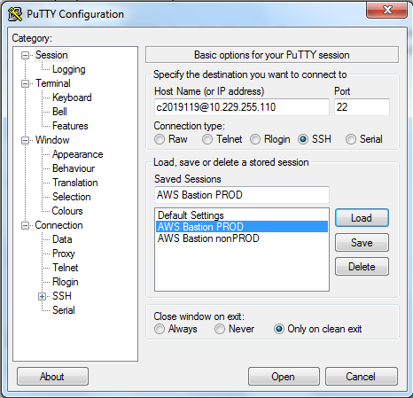

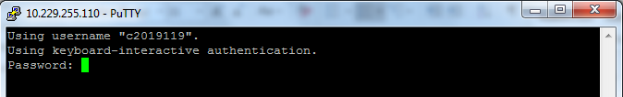

* 1. Enter username
  2. Enter password: Pin+Token
  3. Right click on the top left corner of the putty window

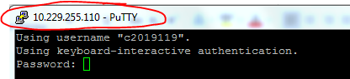

* 1. Click on ***Change settings***
  2. Putty reconfiguration window will open, expand ***SSH*** and click on ***Tunnels***
  3. In **Source port** enter 127.0.0.2:13389 (127.0.0.2 is the loopback IP and 13389 is the source port). For every new Windows instance you need to login, use a different IP or different port.
  4. In the **Destination** enter the <Windows EC2 App Server IP>: 3389 [RDP port is 3389] (ex: 10.229.237.46:3389)
  5. Click on ***Add***, the IPs will be added, then click on this L1 configuration (highlighted in blue) and click on ***Apply***:

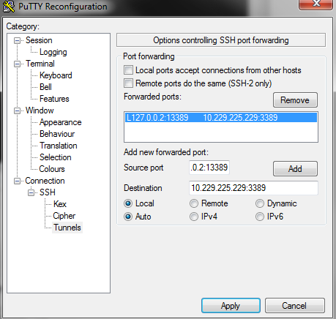

An option is to just specify the Source port as: 13389

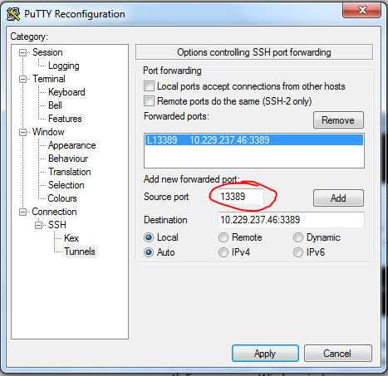

And the RDP like this:

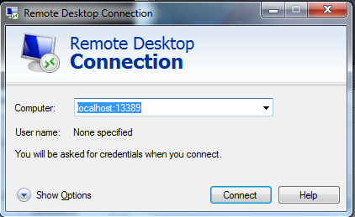

1. Setting up RDP Connection
   1. Open Notepad and save it as ***MyWindowsServer.rdp***; make sure to use the extension .rdp to save this file. The file will be saved like this:

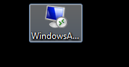

This is what it looks like after opening ***MyWindowsServer.rdp***

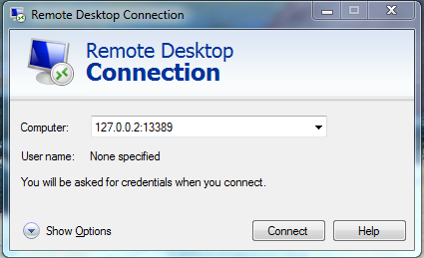

This is the ***Show Options*** view:

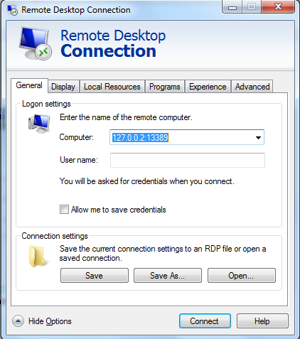

* 1. Open ***MyWindowsServer.rdp*** and select from the drop down list (or enter) the details for ***Computer*** as 127.0.0.2:13389 (the endpoint tunnel).

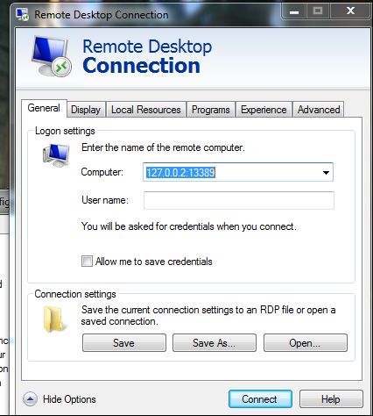

* 1. Click ***Save*** and then click ***Connect***
  2. You will be prompted for your Windows login ID. You can find your **Windows AD login ID** (aka, **CloudAD HPA ID**) here:

<https://oneidm.ge.com/modules/pass_mgmt/reset_pwd.xhtml?faces-redirect=true>

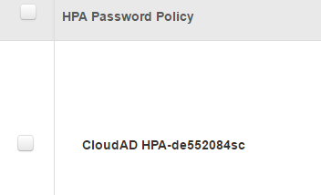

* 1. When prompted for login, change the domain to cc-mgmt\<AD login ID>
  2. Change the domain and then use this domain to login using your password for this ID (you set the password for this ID when you create this ID in IDM; if you do not remember then change the password in IDM by visiting the link above).
  3. In the screen shot below, the AD ID is lg637872sc:

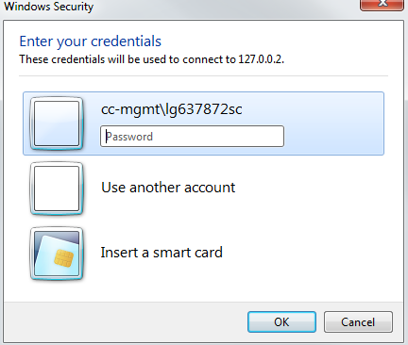

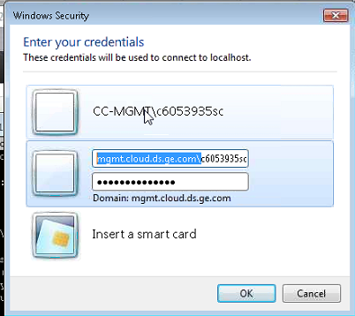

* 1. After entering the details, the RDP connection will start and you will be logged into the windows box.

mgmt.cloud.ds.ge.com\c2019119sc

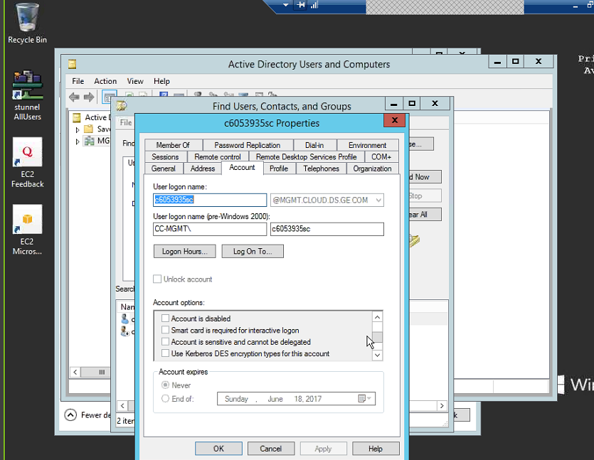

**IDM – CHECKING GROUP MEMBERSHIP (AD & NetGroup)**

Restricted groups that you have been granted explicit permissions to use: <https://idm.ge.com/user/request/HPAAccess/hpa_request_details_removesapm.jsp?op_appName=Security%20Groups&op_SSOID=200019119&op_AccountID=null&lnk=3>

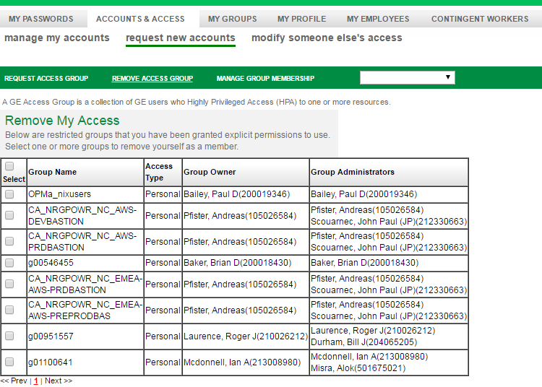

User NetGroup membership: <https://idm.ge.com/authentication/GIS_Unix_Auth_UserNetgroupList.jsp>

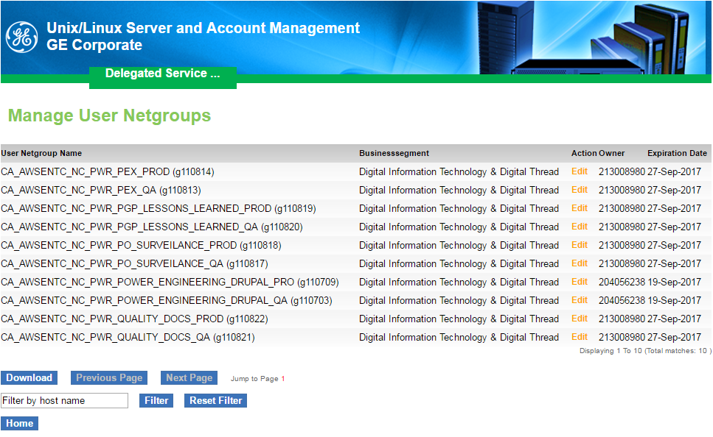

<https://oneidm.ge.com/faces/modules/security_group/businessAdminHome.xhtml>

# **How To Request Personal Access To A CloudAD HPA Group**

***NOTE:***  The process below will grant either your smart card enabled HPA or your password based HPA access to an HPA group.  If you don’t already have a smart card enabled HPA or password-based HPA, the process below can be used to create your smart card enabled or password based HPA upon access approval.

<http://kb.ds.ge.com/i-need/access-to-a-group/groups-cloudad-domain-2/hpa-groups/2/>

**HOW TO CREATE AN AD GROUP**

<https://oneidm.ge.com/home.xhtml>

Manage My Groups 🡪 HPA Server Access 🡪 Group Creation 🡪 [Create a Server Admin Group](https://oneidm.ge.com/modules/security_group/securityGroupCreationHome.xhtml)

Note: Group owners are not automatically members of the group

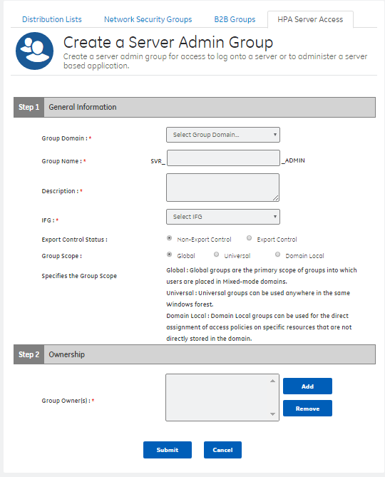

How to update AD Group Membership

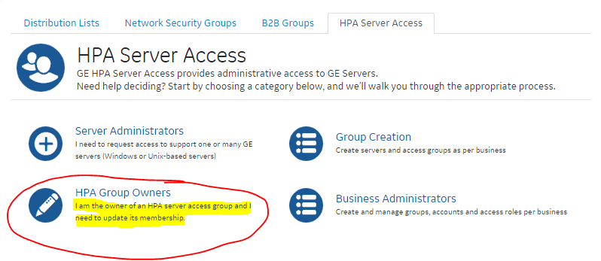

STEPS TO FINISH CONFIGURING SECOND ELB/INGRESS/APACHE (for granite.onthego.gepower.com)

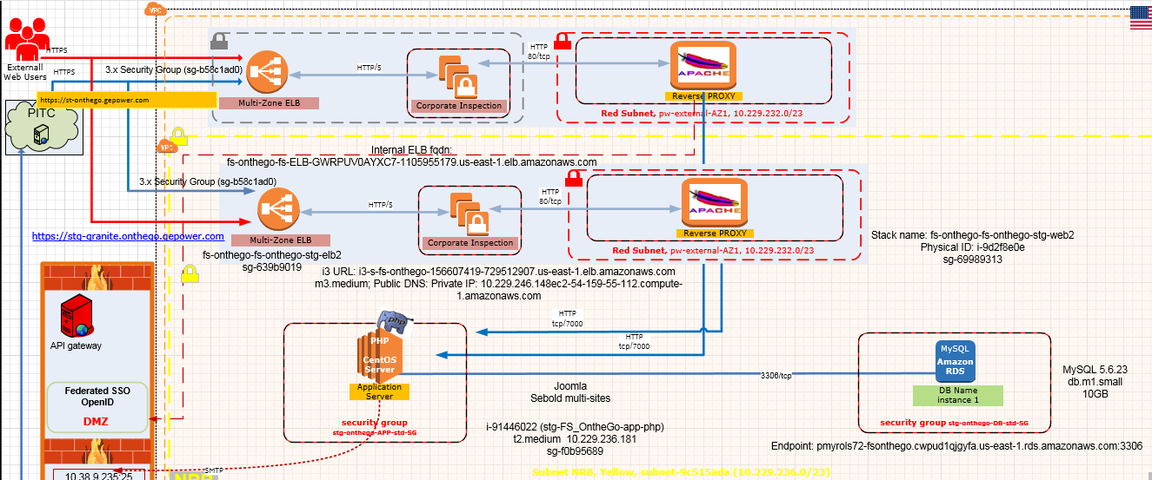

Added new web SG to app server SG, currently app server was accepting connections on 80, 7000, 7001, so I just replicated this for the new web server group.

Ingress → HA Proxy → Granite Web ELB → Granite Web → On The Go App



Submit DNS request for i3-s-fs-onthego-156607419-729512907.us-east-1.elb.amazonaws.com

CHG2335356

Add web server to web ELB.

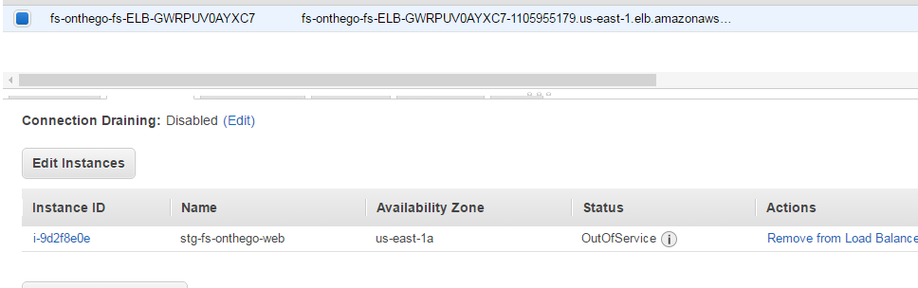

This should be it but I need the DNS change made before I can test and confirm

*Why is the DNS request a ServiceNow RITM in this case vs. Jenkins?*

Since it's internet facing they don't have that automated. Had this been an internal only facing app we would have used Jenkins. Now with that said we need to confirm the Apache config is setup in ssl.conf to ensure its sending traffic to the app server

I edited [**applicationConfig**](https://github.build.ge.com/pw-web/applicationConfig)/[fs-onthego](https://github.build.ge.com/pw-web/applicationConfig/tree/master/fs-onthego)/[fs-onthego-stg](https://github.build.ge.com/pw-web/applicationConfig/tree/master/fs-onthego/fs-onthego-stg)/[ws](https://github.build.ge.com/pw-web/applicationConfig/tree/master/fs-onthego/fs-onthego-stg/ws)/[pw_web_apache2_4](https://github.build.ge.com/pw-web/applicationConfig/tree/master/fs-onthego/fs-onthego-stg/ws/pw_web_apache2_4)/**ssl.conf**.

***OLD***

ProxyPass               /stg-granite.onthego        <http://localhost:7000/stg-granite.onthego>

ProxyPassReverse        /stg-granite.onthego        <http://localhost:7000/stg-granite.onthego>

**NEW***

ProxyPass               /stg-granite.onthego        <http://10.229.236.181:7000/stg-granite.onthego>

ProxyPassReverse        /stg-granite.onthego        <http://10.229.236.181:7000/stg-granite.onthego>

EXAMPLE DNS CHG REQUEST FOR EXTERNALLY FACING APP

(forst-apm-apcom-onthego.gepower.com) - **CHG2405908**

Github path:

<https://github.build.ge.com/pw-web/applicationConfig/tree/master/fs-onthego/fs-onthego-apm-stg/ws/pw_web_apache2_4>

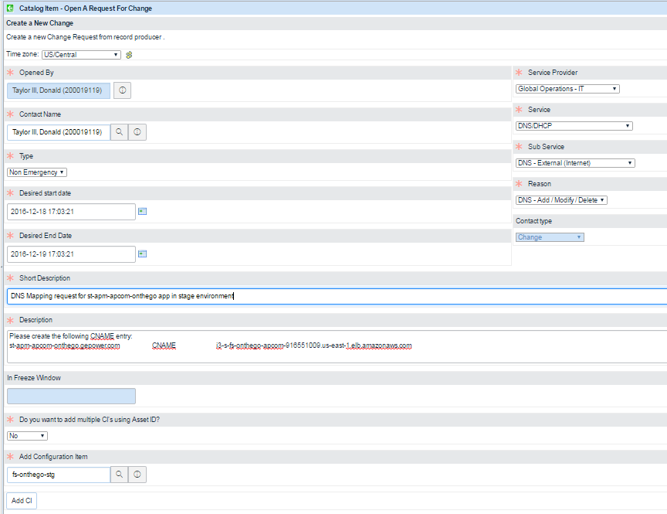

**REQUESTING i3 INGRESS**

Send an email to Shaun or Gabe, for example:

Please create the i3 ingress for the docwareus STG environment.

**Application Name:**

CI = docware us

CF Gen app name = docwareus

**AWS Account:** pnw-prod (988201728534)

**UAI:** UAI2003524

**ElbEndpointDetail:** docwareus-docw-ELB-11KLPFX6Z2202-752093102.us-east-1.elb.amazonaws.com

**FQDN:** st-docwareus.gepower.com

**Target SG (Web ELB):** sg-f6e0bc89

**THE FOLLOWING IS COPIED FROM**

<https://ge.box.com/s/y0atz6xjbk3sg0e2el1yxkd2uswe29o6>

## 1) Ingress request (Stage and Production)

We need Ingress request for **External facing** applications to setup ELB’s on AWS

**Pre-requisites:**

* Corp Registration ID ( <https://gesoftware.service-now.com/> )
* Application URL
* Web Server Security group in AWS
* Web Server IP Address in AWS

To raise Ingress request go to [http://sc.ge.com/*AWSEntIngressReq](http://sc.ge.com/*AWSEntIngressReq) :

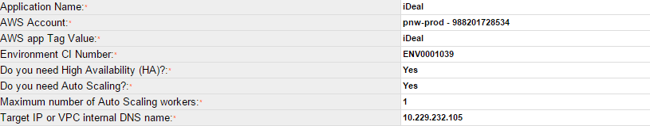

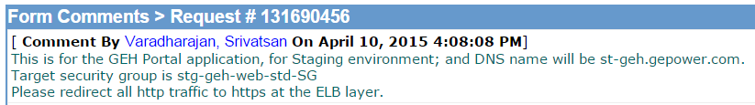

This is for Moduletrac Application, for Staging Environment and DNS name will be stg-moduletrac.gepower.com. Target security group is stg-moduletrac-web-std-sg

Please redirect all http traffic to https at the ELB layer.

Turnaround time to complete the request: 2 to 3 days.

Corporate team will handle this. You can contact Putturao, Shashi (GE Corporate, consultant) [shashi.putturao@ge.com](mailto:shashi.putturao@ge.com)

You will receive an ELB DNS record. E.g.: cb-elb-pw-xxxxxxx-stg-254115372.us-east-1.elb.amazonaws.com

Once implemented, open a DNS change Request to create a new CNAME entries, such as

st-ideal.gewater.com CNAME cb-elb-pw-xxxxxxx-stg-254115372.us-east-1.elb.amazonaws.com

# [**I3 (Internet Ingress Instrumentation) Self Service - Rules of the Road**](https://devcloud.swcoe.ge.com/devspace/display/LDLUN/I3+%28Internet+Ingress+Instrumentation%29+Self+Service+-+Rules+of+the+Road)

<https://devcloud.swcoe.ge.com/devspace/display/LDLUN/I3+%28Internet+Ingress+Instrumentation%29+Self+Service+-+Rules+of+the+Road>

**To request an i3 setup for your application you need to raise a request at** [http://sc.ge.com/*i3Request](http://sc.ge.com/*i3Request)

(this is from <https://devcloud.swcoe.ge.com/devspace/display/LDLUN/Request+ingress+path>)

This process is also deprecated. Go here: <https://devcloud.swcoe.ge.com/devspace/display/SGYXB/AWS+Builds+-+Service+Requests>

* Where it says: [1) Ingress request (Stage and Production) - do not follow this process.  There is a new new process.  contact Shaun Border !!](https://devcloud.swcoe.ge.com/devspace/display/SGYXB/AWS+Builds+-+Service+Requests#AWSBuilds-ServiceRequests-1)Ingressrequest(StageandProduction)-donotfollowthisprocess.Thereisanewnewprocess.contactShaunBorder!!)

**EXTERNALLY FACING APP**

NOTE: Shaun recommended using the CF Gen INTERNALNonHA.json stack and then selecting **Externally facing** in the Apache configuration. The VPC needs to be selected as **US-prod** and the environment as **STG** or **PROD**.

fqdn should be: <*appname*>.gepower.com

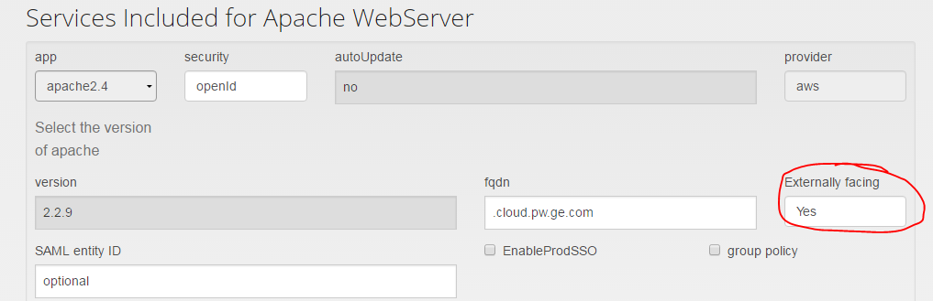

The option seems to be to select the EXTERNALNonHA.json stack which defaults to US-prod and STG. However the Apache Externally facing selection still needs to be Yes.

What is the correct FQDN for externally facing apps? **gepower.com**

1. Use CF Gen to build stack (ELB, Apache, App)
2. Build i3 in front of ELB
3. Once i3 is deployed, open ticket with the Security team to set up WAF: <https://devcloud.swcoe.ge.com/devspace/pages/viewpage.action?pageId=1134677219>

This is from <https://devcloud.swcoe.ge.com/devspace/pages/viewpage.action?pageId=1134677219>

*Web Application Firewall (WAF), is a cloud solution used to protect GE Power Internet-facing web sites. The solution is provided by Imperva and the Power IT Security Team. The Security team is responsible for deploying and monitoring the tool.*

* *WAF is needed for all external applications.*
* *WAF is setup by the Power Web team and not the Solution Architects*
* *Josh Davis had a training on WAF and there is technical information found in box.ge.com*[*https://ge.box.com/s/kgh6rrvk8geink9mdr8gou9c2obwbcly*](https://ge.box.com/s/kgh6rrvk8geink9mdr8gou9c2obwbcly)

*The following steps must be followed to set up WAF for your application: (NOTE: These steps should be done****before****you request that the DNS team set up a CNAME entry to the new externally-facing endpoint)*

1. *Fill out the Power WAF Provisioning Form*
   1. [*Power WAF Provisioning Form is found at http://forms.ge.com/create/150836*](http://forms.ge.com/create/150836)
2. *Open a request to the @POWER AWS Web Support team to set up the WAF*
   1. *Example:*[*RITM13927342*](https://ge.service-now.com/nav_to.do?uri=sc_req_item.do?sys_id=d89e57b3db387600ea66556fdf961965%26sysparm_view=ISS_SSR_View)
3. Once WAF is set up, submit CHG request to set up DNS

Right now a special role is set up to configure i3 ingress (Shaun and Gabe): AWS Console 🡪 Service Catalog

Configuration notes:

* dp-product-book-stg
* VPC 🡪 Subnet 🡪 Search for Internet 🡪 cb-internet-AZ*
* Pick subnet with highest number of available IP addresses
* i3 needs to span subnets
* ASG = Auto Scaling Group
* WAF form – adjust web configuration

**MORE ON EXTERNALLY FACING APP**

URL: <app_name>.gepower.com

In CFGen, select **No** for Externally Facing

THIS IS FROM THE GRANITE ONTHEGO BUILD:

-- INGRESS --

<http://supportcentral.ge.com/caseforms/sup_myforms.asp?form_doc_id=156503853&node_id=1702174> [This SC workflow appears to be deprecated]

App name: fs-onthego

AWS Account: pnw-prod - 988201728534

UAI Tag Value: UAI1010801

Environment CI Number: 1001927091

Min number of instances in Autoscaling group: 1

Max number of instances in Autoscaling group: 1

Internal ELB FQDN: fs-onthego-fs-ELB-GWRPUV0AYXC7-1105955179.us-east-1.elb.amazonaws.com

Application Environment: stage

i3 URL: i3-s-fs-onthego-156607419-729512907.us-east-1.elb.amazonaws.com

Instance ID: i-42bf0fd1

Instance type: m3.medium

Private IP: 10.229.246.148

Public DNS: ec2-54-159-55-112.compute-1.amazonaws.com

Public IP: 54.159.55.112

IAM role: vESG-EC2-Role

## 2) DNS Change Request

To raise DNS Change, go to <https://ge.service-now.com/>

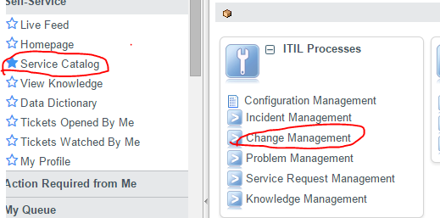

#### a) for External Applications

njmhhgk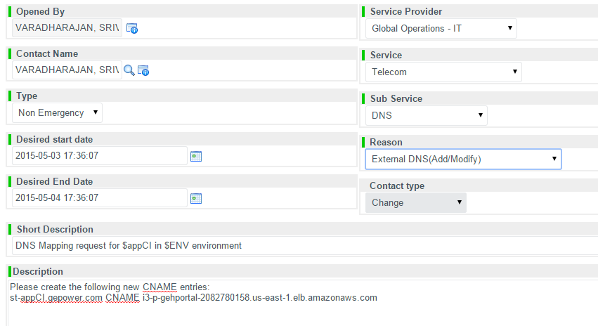

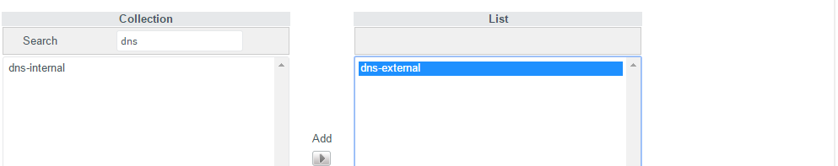

Turnaround time to implement at max: 2 to 3 days.

It will be handled by corporate team and you can contact @CORP DNS Team.

5. Create the i3 ingress for the docwareus STG environment (email to Shaun a/o Gabe)

Application Name:

CI = docware us

CF Gen app name = docwareus

AWS Account: pnw-prod (988201728534)

UAI: UAI2003524

ElbEndpointDetail: docwareus-docw-ELB-11KLPFX6Z2202-752093102.us-east-1.elb.amazonaws.com

FQDN: st-docwareus.gepower.com

Target SG (Web ELB): sg-f6e0bc89

(4/25 - from Shaun)

I3 ELB - i3-s-docwareus-1438531027.us-east-1.elb.amazonaws.com (this is what you will provide to Raju to setup the WAF).

EC2 (HA Proxy) SG - sg-0520297a - This has been added to the web ELB you setup for docwareus.

docwareus-docw-ELB-11KLPFX6Z2202-752093102.us-east-1.elb.amazonaws.com

Name: i3-s-docwareus-LB

Instance ID: i-0579ed89071fdda8d

6. DNS CHG Request for Externally facing app - CHG2553957

Once the i3 is deployed, submit a CHG Request to create DNS entry for externally facing app

(from Gabe)

Just a heads up, before you reach out to Raju, make sure that you get the DNS entry for the site tied to this i3 endpoint.

He requires that the entry is created (meaning the DNS CHG ticket needs to be completed), before he ties it to the WAF endpoint.

That’s a hurdle I’ve had to go through a few times. I noticed the documentation has an error, so I’m updating it now to account

for that.

Short Description: DNS mapping request for Docwareus application in STG environment

Description: Please create the following new DNS CNAME entry:

st-docwareus.gepower.com CNAME i3-s-docwareus-1438531027.us-east-1.elb.amazonaws.com

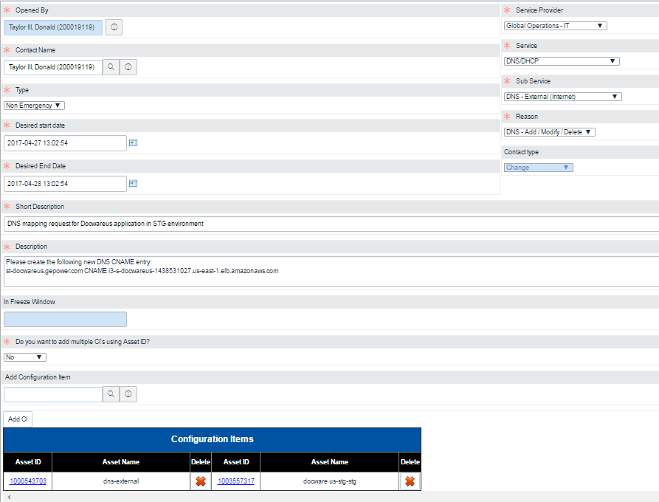

7. Once the DNS CHG is completed, open ticket with the Security team to set up WAF: https://devcloud.swcoe.ge.com/devspace/pages/viewpage.action?pageId=1134677219

So next step is to engage Raju for Waf Setup. If not already done so you will need to submit the WAF data form.

https://devcloud.swcoe.ge.com/devspace/pages/viewpage.action?pageId=1134677219

THIS IS FROM THE **DP-PRODUCT-BOOK** BUILD:

I have updated the I3 again to terminate the SSL on the ELB.  Setup the rest of the application and put the cert on the ingress.  Register DNS and then we can test it.

Hi Vatsan & Shaun,

Can I get one of your assistance at installing the paid certs for external application st-dpproductbook.gepower.com?  Shaun has already built the i3:

**Instance:  i-0c6c42d210898e414 (i3-s-dp-product-book-vESG-Instances)Public DNS: ec2-54-158-104-235.compute-1.amazonaws.com**

The URL has not yet been registered.

|  |  |
| --- | --- |
| **Application Name (CI)** | dp-product-book |
| **Asset ID** | 1003201901 |
| **URL** | st-dpproductbook.gepower.com |
| **UAI** | UAI2005656 |

-from Shaun- *Here are some steps*:

<https://devcloud.swcoe.ge.com/devspace/display/SGYXB/Assigning+an+SSL+Cert>

*look at the Register the cert external sites section*

-from Rob - Certs are uploaded to the elb in front of the I3.  (The instructions say to put the certs on the ELB in front of the WebServer, but Vatsan set me straight…)

The External DNS request is submitted as **Change Request CHG2646458**

I will submit the WAF Ticket after DNS is complete.

#### b) for Internal application

**Pre – requisites:**

* Application URL: dev-ibom.pw.ge.com
* Apache Web Server IP address: 10.227.224.128

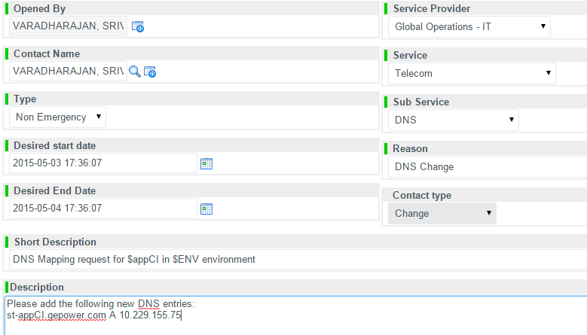

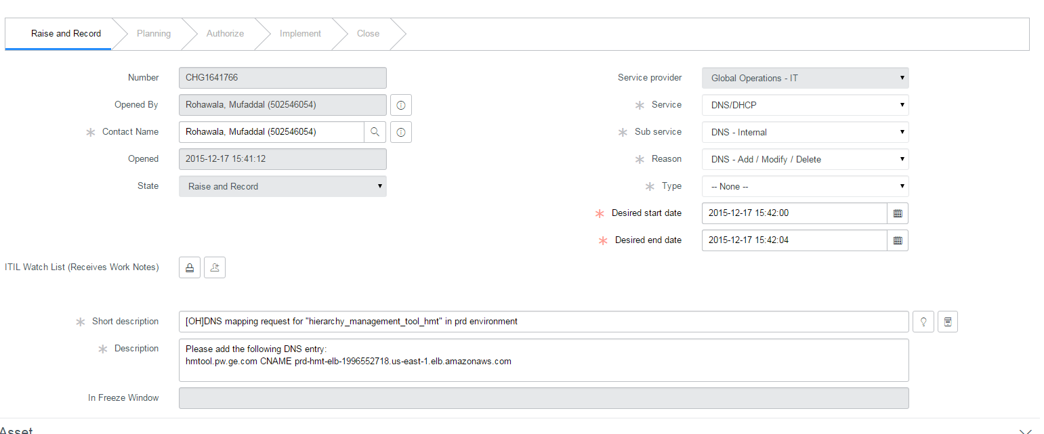

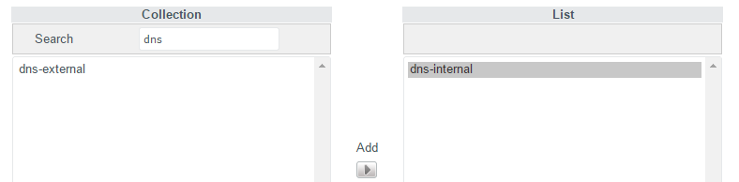

Turnaround time to implement at max 2 to 3 days

It will be handled by corporate team and you can contact @CORP DNS Team

## 3) SAML (SSO) Request

SSO Authentication for accessing the application and configuration changes to be done in Apache Web Server.

**Pre- requisites:**

* FQDN : dev-ibom.pw.ge.com
* Entity ID : pww-ibom-web-dev
* Staging and Prod SSO access: <http://supportcentral.ge.com/ProcessMaps/form_new_request.asp?prod_id=14927&form_id=352731&node_id=903811&map_id=&reference_id=&reference_type>=

To Raise SSO request, go to <https://ge.service-now.com/>

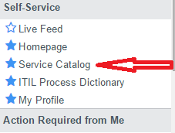 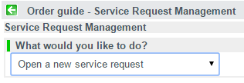

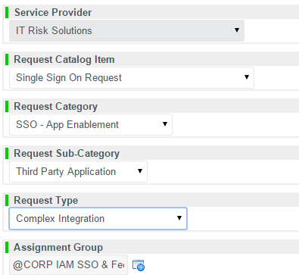 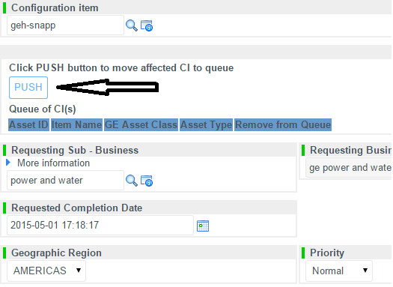

**See below for the remainder of the fields in the ticket**.

===============================================================

|  |
| --- |
| **Short description:** New SAML setup for “applicationCI” in ENV |
| **Description:** Please create a new application mapping with the following attributes:    ENTITYID=pw-appCI-web-ENV  FQDN=dev-pgelk.pw.ge.com  See **attached service provider metadata XML file**  User Policy: GE worker  User Store: Production Users - Please provide PROD SSO account access for this PROD env  Required attributes from the IDP: sso, firstname, lastname, email |

===============================================================

* Entity ID format: bu-appci-WEB-env
* Where:
  + bu = Business unit abbreviation. For example, ‘og’ for Oil & gas or ‘pw’ for Power & Water
  + appname = is the name of your application.
  + env = is the type of environment your application instance is running in. For example, ‘stg’ for staging, ‘prd’ for production.
* Examples:
  + pw-gedistrib-web-stg
  + av-sptc-prd
  + og-dre-aex-bsr-qa
* Metadata XML file:



Replace $FQDN with the application URL, and replace $ENTITYID with the right one. Save the file as “SP-entityID.xml”. E.g.: SP-pw-elkpgp-web-dev.xml

Turnaround time to completed it at max 2 to 3 days

It will be handled by corporate team and you can contact @CORP IT Risk Solutions SSO Integrations

## 4) CSR Creation

The CSR file is needed for submitting the request for signed SSL certificates.

**Pre-requisites :**

* Application’s FQDN
  + It is very important that this FQDN is the correct one.

**To create the CSR**, login to the appropriate Bastion and enter the below command:

HOST=geh.gepower.com

echo "US

NY

Schenectady

General Electric Company

Power&Water Technology Cloud Team

dev-spatsl.power.ge.com

pw.webadmins@ge.com

" | openssl req -nodes -newkey rsa:2048 -keyout dev-spatsl.power.ge.com.key -out dev-spatsl.power.ge.com.csr

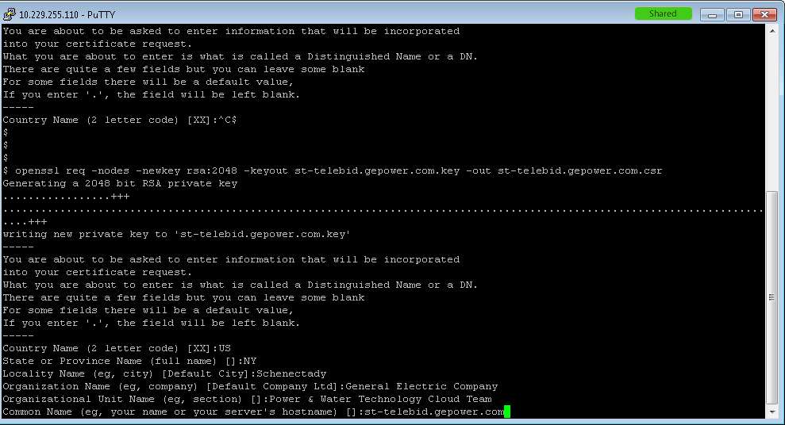

# (optional) verify the content of the CSR  
#openssl req -in $HOST.csr -noout -text

Once the CSR and key files are generated, proceed to the next page.

The key file generated here will be sent/uploaded along with the SSL certificates, depending on the application being internal or external facing.

## 5) Signed SSL Certificates

To Encrypt Sensitive Information and Authentication

**Pre-requisites :**

* BUC/ADN
* Certificate Signing Request (CSR)

To raise cert request, go to <http://certificates.ge.com/>

Enter the application specify BUC/AND (<http://forms.ge.com/records/28002>)

In the next page, attach or paste the CSR (the entire file’s contents).

Enter the below details.

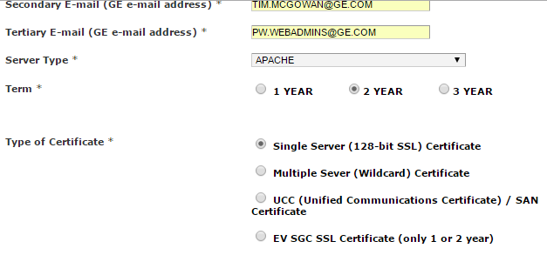

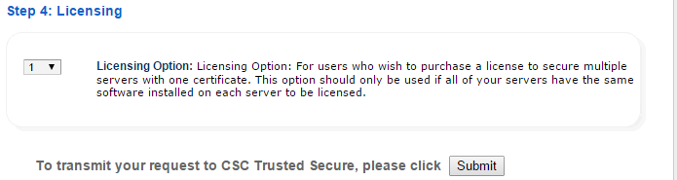

Turnaround time to completed the request is 4 to 6 hours

It will be handled by CSC company and you can contact CSC_Trusted_Secure <csctrustedsecure@cscinfo.com>

**Once you receive the certificates then send them to** [**shashi.putturao@ge.com**](mailto:shashi.putturao@ge.com) **for uploading on the respective application ELB**

## 6) Self-signed SSL certificate

HOST=poc.pw.ge.com

## make sure to add the entry to /etc/hosts, so Apache does not complain on startup

echo "127.0.0.1 $HOST" | sudo tee -a /etc/hosts

### Issue self-signed certificate

#the -req command will ask for the following answers: Country

#        Country Name (2 letter code) [XX]:US

#        State or Province Name (full name) []:NY

#        Locality Name (eg, city) [Default City]:Schenectady

#        Organization Name (eg, company) [Default Company Ltd]:General Electric Company

#        Organizational Unit Name (eg, section) []:Power&Water Technology Cloud Team

#        Common Name (eg, your name or your server's hostname) []:poc.pw.ge.com

#        Email Address []:pw.webadmins@ge.com

cd $HOME

# supply all the answers at once

echo "US

NY

Schenectady

General Electric Company

Power&Water Technology Cloud Team

$HOST

pw.webadmins@ge.com" | sudo openssl req -x509 -nodes -days 365 -newkey rsa:2048 -keyout $HOST.key -out $HOST.crt

sudo chmod 400 $HOST.key

sudo mkdir -p /etc/httpd/ssl

sudo mv $HOST.* /etc/httpd/ssl

### Create SSL config file

cd /etc/httpd/conf.d

# make sure the logs folder is also directly accessible

sudo chgrp gecloud /var/log/httpd && sudo chmod g+r+X /var/log/httpd && sudo chmod g+r /var/log/httpd/*

# create a "fake" ssl.conf, because sometimes the Apache installer decides to put the default when it does not find the file

# and this can mess things up

sudo mv ssl.conf ssl.conf.default

# it is expected the user gecloud can write to this folder, if not

sudo chown -R gecloud .

sudo touch ssl.conf

# create a new config file

sed "s/\$HOST/$HOST/" ssl-config.template > ssl-$HOST.conf

# absorb changes

sudo service httpd restart

# test

curl -v <http://localhost> > /dev/null

curl -k -v <https://localhost> > /dev/null

-------------------------------------------- end of document copy ---------------------------------------------------------------

## 7) Windows Active Directory User Group request

To provide access for the App team to the Windows server.

**Prerequisites**:

* Collect the list of SSO users that will be authorized to login to the server (as local admins)
  + Team members to be added
  + Primary Owner
  + Secondary Owner
* User Group 🡪 SVR_GE009000000_appCI_Admin
* IMPORTANT: It should be "MGMT.cloud" domain
  + Unless mentioned otherwise by the app team.

**Steps**:

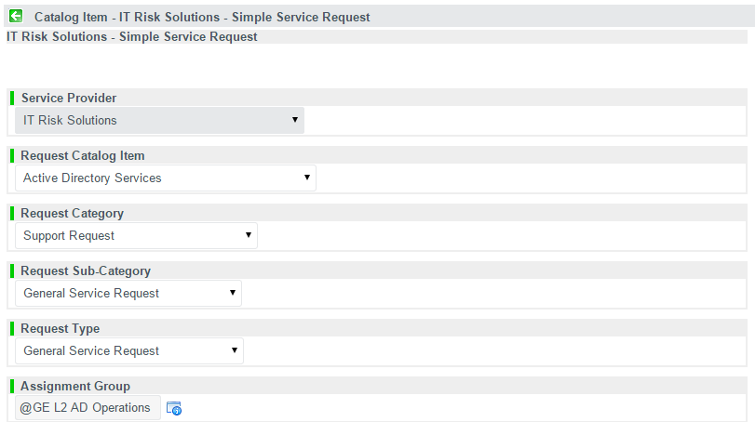

|  |
| --- |
| **Short description:** Create Windows Active Directory User Group, for $app_CI |
| **Description:** Description:  App Name: SNAPP  (SVR_GE009000000_SNAPP_Admin)  Team members to be added:  • Last1, First1 (SSO1)  • Last2, First2 (SSO2), ……    Primary Owner: Last, First (SSO)  Secondary Owner: Last, First (SSO)    IMPORTANT: It should be "MGMT.cloud" domain.    Please provide a List of Members of this group once added. For users who do not have an account, could you please create an HPA account and then add the same?  Request password change for users on their first login. |

## 8) Appadmin access for app team, to application server on AWS Servers (refer the cloud access document for detailed steps)

To provide access to App team on AWS servers to deploy there code on Application server

**Pre-requisites:**

* public key which generated in bastion host
* application server IP address

**How to provide access**:

1. Login into respective Application server
2. Add the publickey to the ***authorized_keys*** file under /home/appadmin/.ssh
   1. cd /home/appadmin/.ssh/
   2. vi authorized_keys
   3. Switch to INSERT mode (by hitting Esc and then Insert key)
   4. Paste the public key of the new user(s) in a new line(s).
   5. Save the file (by hitting Esc and then type :wq! )
3. Then app team can login from bastion host as below
   1. ssh appadmin@xxxxxx
   2. where, ‘xxxxxx’ is the application server IP address

**SSL CERTIFICATES**

 Here you go, I’m sure this leaves a lot of questions let me know and we can work on this together.

Cert request location: /opt/software/apache/ssl

SSL certs

Thursday, March 19, 2015

4:22 PM

* 1. If app is **externally facing**, the certs need to be added to i3. On the ingress ELB, add an HTTPS listener and add the certificate.
     1. Open a text editor (such as wordpad) and paste the entire body of each certificate into one text file in the following order:

OV_NetworkSolutionsOVServerCA2  
OV_USERTrustRSACertificationAuthority  
AddTrustExternalCARoot

Pasted from <[*http://serverfault.com/questions/643401/cant-get-network-solutions-certificate-chain-working-with-ec2-elastic-load-bala*](http://serverfault.com/questions/643401/cant-get-network-solutions-certificate-chain-working-with-ec2-elastic-load-bala)>

* 1. If app is **internally facing**, we need to:
     1. Upload the certificate and chain to github, under the web server's "ssl" folder.
     2. Update the "[apache_list_file.json](https://github.build.ge.com/pw-web/applicationConfig/blob/master/primavera/p6cc-1-prd/ws/pw_web_apache/apache_list_file.json)" file as well.
     3. (If needed) Update the ssl.conf file as well, for the CA chain file.

* 1. If some of the users see **certificate warning**, while others do not (probably on different browsers), even though the certificates are generated by CSC Trusted Secure, then it because of one of the following reasons:
     1. CA chain file is missing.
     2. CA chain file is added, but the intermediates are not in the correct order. Should be in this order
        1. TrustedSecureCertificateAuthority5.ccc
        2. USERTrustRSAAddTrustCA.ccc
        3. AddTrustExternalCARoot.ccc

## 4) Signed SSL Certificates

To Encrypt Sensitive Information and Authentication

**Pre-requisites :**

* BUC/ADN
* Certificate Signing Request (CSR) – from the PROD web apache (so obviously, this needs to be built first)

1. To raise cert request, go to <http://certificates.ge.com/>
2. Enter the application specify BUC/AND (<http://forms.ge.com/records/28002>)
3. In the next page, attach or paste the CSR (the entire file’s contents).
   1. Since the cookbook creates self-signed certificates by default, save the CSR and KEY files from the Apache’s SSL folder to your machine. For example: [**applicationConfig**](https://github.build.ge.com/pw-web/applicationConfig)/[power-engineering-drupal](https://github.build.ge.com/pw-web/applicationConfig/tree/master/power-engineering-drupal)/[power-engineering-drupal-prod](https://github.build.ge.com/pw-web/applicationConfig/tree/master/power-engineering-drupal/power-engineering-drupal-prod)/[ws](https://github.build.ge.com/pw-web/applicationConfig/tree/master/power-engineering-drupal/power-engineering-drupal-prod/ws)/[pw_web_apache2_4](https://github.build.ge.com/pw-web/applicationConfig/tree/master/power-engineering-drupal/power-engineering-drupal-prod/ws/pw_web_apache2_4)/[ssl](https://github.build.ge.com/pw-web/applicationConfig/tree/master/power-engineering-drupal/power-engineering-drupal-prod/ws/pw_web_apache2_4/ssl)/**power-engineering-drupal.power.ge.com.csr**
4. Enter the below details: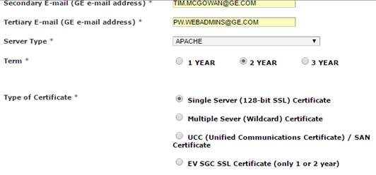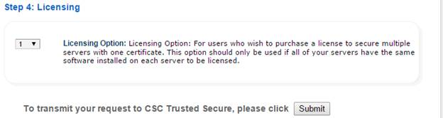SLA: 4 to 6 hours
5. It will be handled by CSC company and you can contact CSC_Trusted_Secure [csctrustedsecure@cscinfo.com](mailto:csctrustedsecure@cscinfo.com)
6. Once done, you will receive the certificate (.ccc) and CA chain in 3 different files
7. Certificate upload

**See:** <https://devcloud.swcoe.ge.com/devspace/display/SGYXB/Assigning+an+SSL+Cert>

## Register the Cert for Internal Sites

1. The file named **“<*application name*>.ccc”** provided by the CSC Certificate Authority in response to the certificate request, will replace the existing **\*.crt** file, which is located at (for example):

[**applicationConfig**](https://github.build.ge.com/pw-web/applicationConfig)/[fs-onthego](https://github.build.ge.com/pw-web/applicationConfig/tree/master/fs-onthego)/[fs-onthego-stg](https://github.build.ge.com/pw-web/applicationConfig/tree/master/fs-onthego/fs-onthego-stg)/[ws](https://github.build.ge.com/pw-web/applicationConfig/tree/master/fs-onthego/fs-onthego-stg/ws)/[pw_web_apache2_4](https://github.build.ge.com/pw-web/applicationConfig/tree/master/fs-onthego/fs-onthego-stg/ws/pw_web_apache2_4)/[ssl](https://github.build.ge.com/pw-web/applicationConfig/tree/master/fs-onthego/fs-onthego-stg/ws/pw_web_apache2_4/ssl)/**stg-granite.onthego.gepower.com.crt**

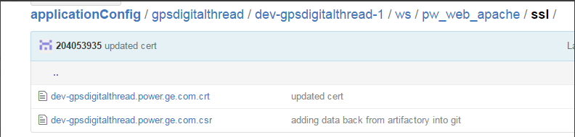

1. First make a backup copy of the existing **\*.crt** file and store it in the Box project folder.
2. Next, open the CSC Certificate Authority **“<*application name*>.ccc”** file in Notepad; select all to copy the entire contents (including the “-----*BEGIN CERTIFICATE*-----“ and “-----*END CERTIFICATE*-----“ header and footer).
3. In the …/[ws](https://github.build.ge.com/pw-web/applicationConfig/tree/master/power-engineering-drupal/engineering-prd/ws)/[pw_web_apache2_4](https://github.build.ge.com/pw-web/applicationConfig/tree/master/power-engineering-drupal/engineering-prd/ws/pw_web_apache2_4)/[ssl](https://github.build.ge.com/pw-web/applicationConfig/tree/master/power-engineering-drupal/engineering-prd/ws/pw_web_apache2_4/ssl)/folder, open and edit the existing **\*.crt** file, paste (and thereby replace) the contents of the new **“<*application name*>.ccc** file; commit the changes.
4. The other 3 files provided by the CSC Certificate Authority are to be used to create the cert chain.  This is done by concatenating the three files in this order:
   * 1. TrustedSecureCertificateAuthority5
     2. USERTrustRSAAddTrustCA
     3. AddTrustExternalCARoot
5. Copy and paste the entire contents of each file, in order, into a Notepad file named “ca-chain.crt”. Make sure to save the file **without** the “.txt” extension (select “All Files (*.*)”)
6. This file needs to be added to the …/[ws](https://github.build.ge.com/pw-web/applicationConfig/tree/master/power-engineering-drupal/engineering-prd/ws)/[pw_web_apache2_4](https://github.build.ge.com/pw-web/applicationConfig/tree/master/power-engineering-drupal/engineering-prd/ws/pw_web_apache2_4)/[ssl](https://github.build.ge.com/pw-web/applicationConfig/tree/master/power-engineering-drupal/engineering-prd/ws/pw_web_apache2_4/ssl)/folder; click **Upload files** and navigate to the “ca-chain.crt” file (in Box).

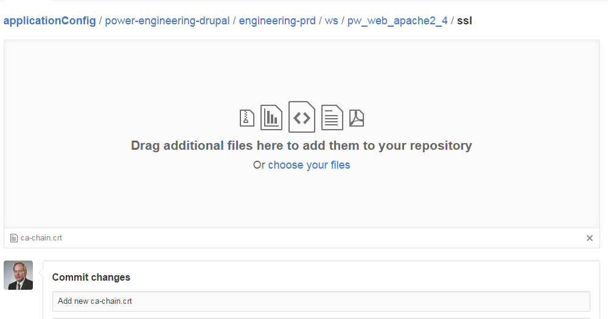

This shows the new “ca-chain.crt” file added to the folder:

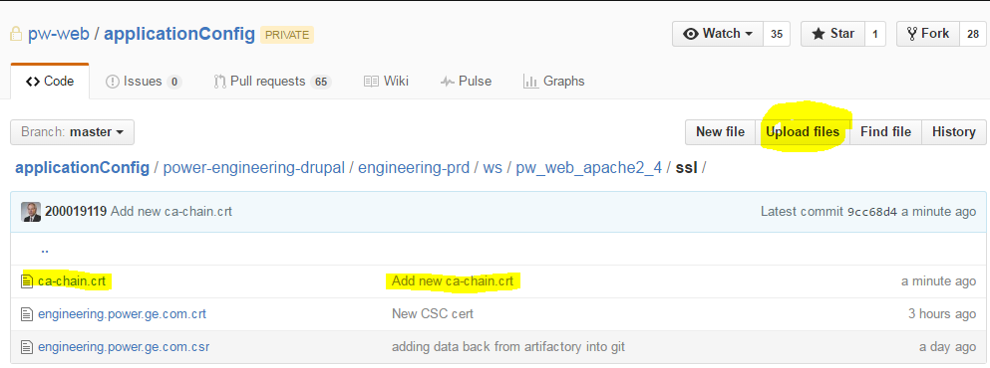

1. Modify (edit) the ssl.conf file to uncomment the mapping to ca-chain.crt file (remove the ‘#’).  
    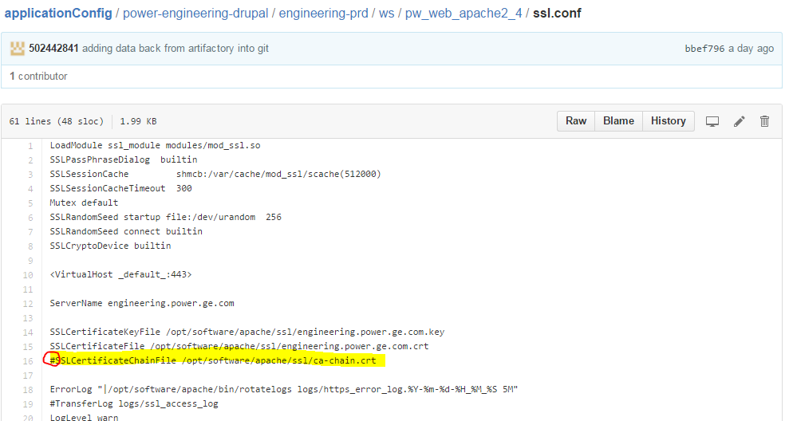
2. Lastly, update the list_file.json file to add the ***ca-chain.crt***.  This file is located in the **applicationConfig/<application>/<application Instance>/web/** folder.

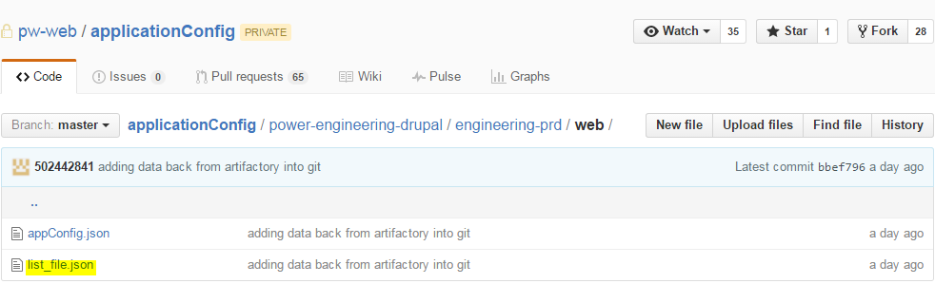

1. Add the ca-chain.crt into the list_file.json.  
    {

"source_file_path": "/SXZZG/Applications/power-engineering-drupal/engineering-prd/ws/pw_web_apache2_4/ssl/ca-chain.crt",

"source_provider": "artifactory",

"localpath": "/opt/software/apache/ssl/ca-chain.crt",

"file_owner": "webadmin",

"file_group": "apache",

"file_mode": "0750",

"notifies_r_type": "service",

"notifies_r_name": "httpd",

"notifies_r_action": "restart"

},

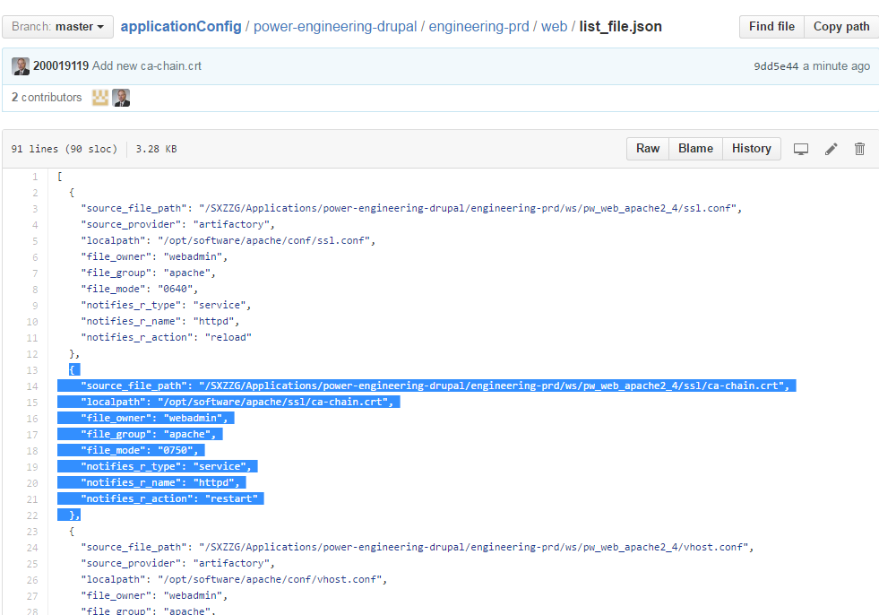

1. The file will be automatically moved onto the web node.

**DEBUG – CERTS NOT WORKING and EDIT DISABLED**

Does this get merged with the file I see here?

<https://github.build.ge.com/pw-web/applicationConfig/blob/b4512d6ee1ce45f7fac74c8ad734062ebaa9904b/quality-docs/quality-docs-prod/web/list_file.json>

**From:** Sayyad, Naseer (GE Power, Non-GE)   
**Subject:** RE: Cert not working for quality-docs

Could you try editing using the below url

<https://github.build.ge.com/pw-web/applicationConfig/blob/master/quality-docs/quality-docs-prod/web/list_file.json>

But I can’t edit it directly; says I have to be on a branch.  How do I create a branch?

Highlighted in red. Remove extra quote

"localpath": ""/opt/software/apache/ssl/ca-chain.crt",

s   
Naseer Sayyad   
Cloud Automation Engineer

**Subject:** Cert not working for quality-docs

Would you take a look at [**applicationConfig**](https://github.build.ge.com/pw-web/applicationConfig/tree/b4512d6ee1ce45f7fac74c8ad734062ebaa9904b)/[quality-docs](https://github.build.ge.com/pw-web/applicationConfig/tree/b4512d6ee1ce45f7fac74c8ad734062ebaa9904b/quality-docs)/[quality-docs-prod](https://github.build.ge.com/pw-web/applicationConfig/tree/b4512d6ee1ce45f7fac74c8ad734062ebaa9904b/quality-docs/quality-docs-prod)/[web](https://github.build.ge.com/pw-web/applicationConfig/tree/b4512d6ee1ce45f7fac74c8ad734062ebaa9904b/quality-docs/quality-docs-prod/web)/**list_file.json**

<https://github.build.ge.com/pw-web/applicationConfig/blob/b4512d6ee1ce45f7fac74c8ad734062ebaa9904b/quality-docs/quality-docs-prod/web/list_file.json>

SSL for <https://quality-docs.power.ge.com/> is not working.  I installed the new certs but must have messed something up.  Plus the list_file.json seems to be highlighting some issue but I don’t know what it is.  What do these highlights indicate?

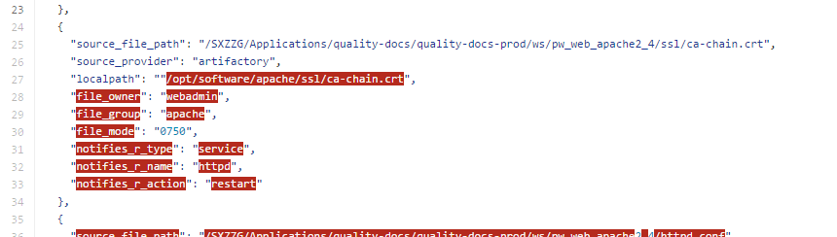

**The list_file is on a branch 🡪 Need to be on the Master (trunk):**

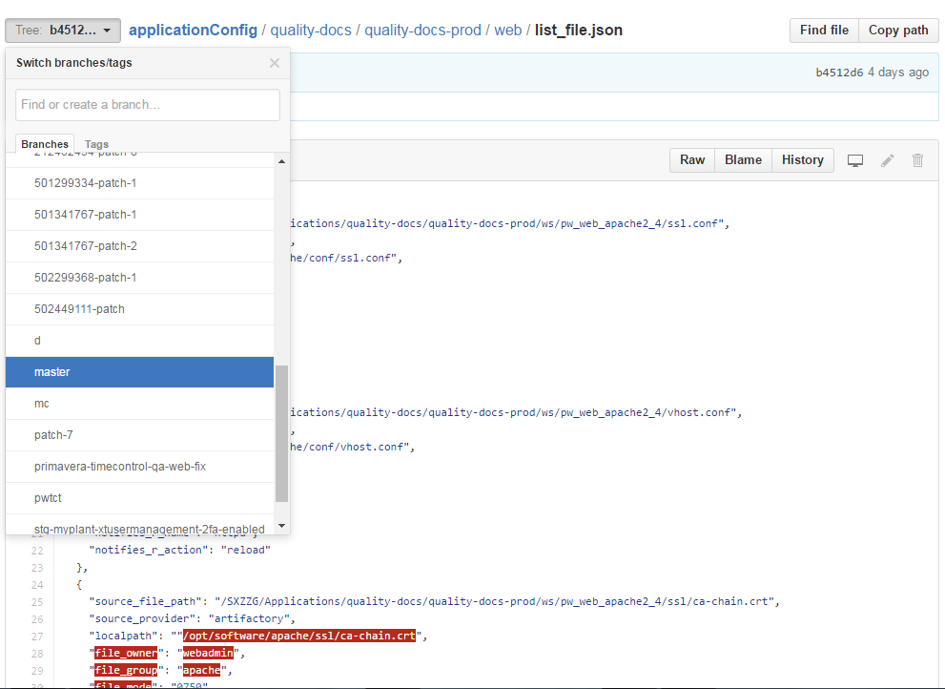

**Hi Mufi, regarding the certs for po-surveilance, i see your updates in Git but i don't see the chain file, shouldn't that be there too?**

**Rohawala, Mufaddal (GE Power, Non-GE)**

**yeah it should be there**

**Taylor III, Donald (GE Power)**

**shouldn't i find it here? https://github.build.ge.com/pw-web/applicationConfig/tree/master/po-surveilance/po-surveilance-prd/ws/pw_web_apache2_4/sslRohawala, Mufaddal (GE Power, Non-GE)**

**https://github.build.ge.com/pw-web/applicationConfig/blob/master/po-surveilance/po-surveilance-prd/ws/pw_web_apache2_4/ssl/po-surveilance.power.ge.com.crtTaylor III, Donald (GE Power)**

**oh, i see, it's embedded in the crt**

**that's different than the instructions Shaun wrote up but if it works i'm good with it**

**seems to work fine, thanks much**

## Register the Cert External Sites

1. In the AWS console for production, go to EC2 🡪 Load Balancers, search and select the ELB in front of web node. For example, i3-p-fs-onthego-157670439. Select the **Listeners** tab.
2. The HTTPS port 443 Listener will be updated.

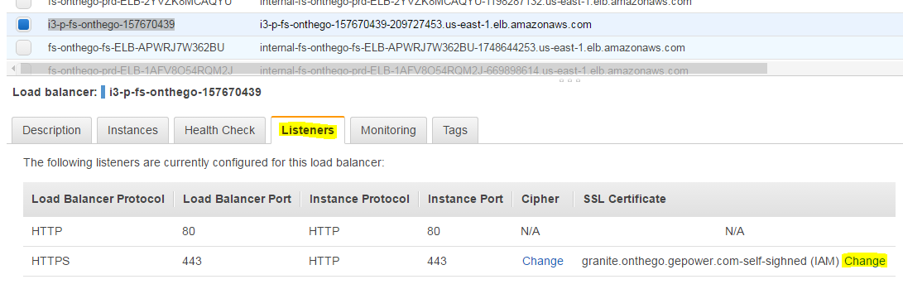

1. Under **SSL Certificates**, click *Change*
2. Select *Upload a new SSL certificate to AWS Identity and Access Management (IAM)*
3. Specify certificate name - try to match the domain name but if it has been used you can specify a different name.
4. The private key can be found in two places, either in Artifactory or on the current web server itself in the SSL folder under Apache. In this example, [granite.onthego.gepower.com.key](https://devcloud.swcoe.ge.com/artifactory/simple/SXZZG/Applications/fs-onthego/prd-fs-onthego/ws/pw_web_apache2_4/ssl/granite.onthego.gepower.com.key) is the private key. The private key file is generated when the CF Gen job is run.

Artifactory: <https://devcloud.swcoe.ge.com/artifactory/simple/SXZZG/Applications/>

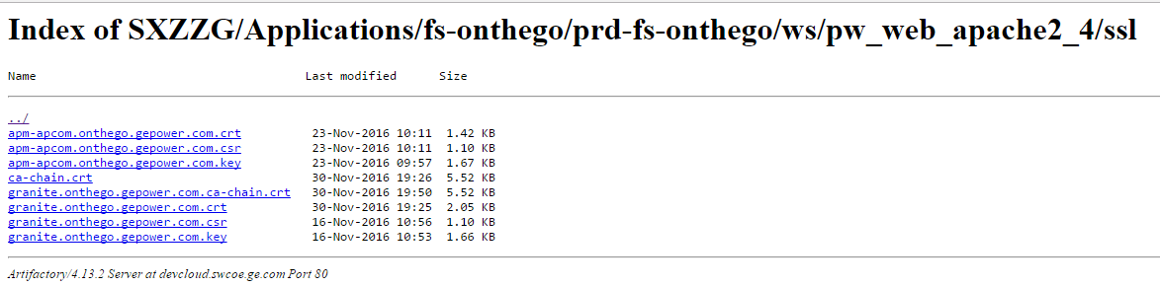

Github (for example): [**applicationConfig**](https://github.build.ge.com/pw-web/applicationConfig)/[fs-onthego](https://github.build.ge.com/pw-web/applicationConfig/tree/master/fs-onthego)/[prd-fs-onthego](https://github.build.ge.com/pw-web/applicationConfig/tree/master/fs-onthego/prd-fs-onthego)/[ws](https://github.build.ge.com/pw-web/applicationConfig/tree/master/fs-onthego/prd-fs-onthego/ws)/[pw_web_apache2_4](https://github.build.ge.com/pw-web/applicationConfig/tree/master/fs-onthego/prd-fs-onthego/ws/pw_web_apache2_4)/**ssl**/

|  |
| --- |
|  |

1. Get the public key certificate from the **“<*application name*>.ccc”** file attachment sent from CSC as a result of the certificate request.
2. The certificate chain needs to be created from the remaining items from CSC, added in this order (TrustedSecureCertificateAuthority5, USERTrustRSAAddTrustCA and AddTrustExternalCARoot.)
3. 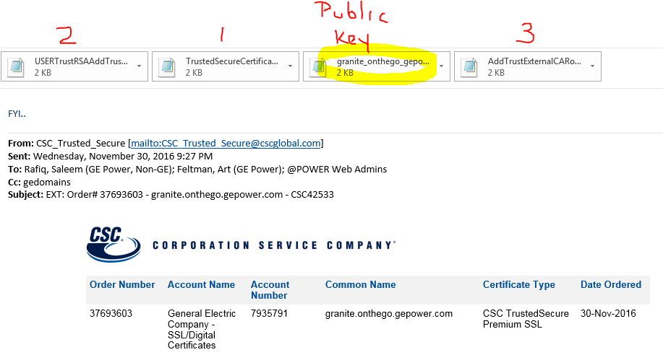
4. 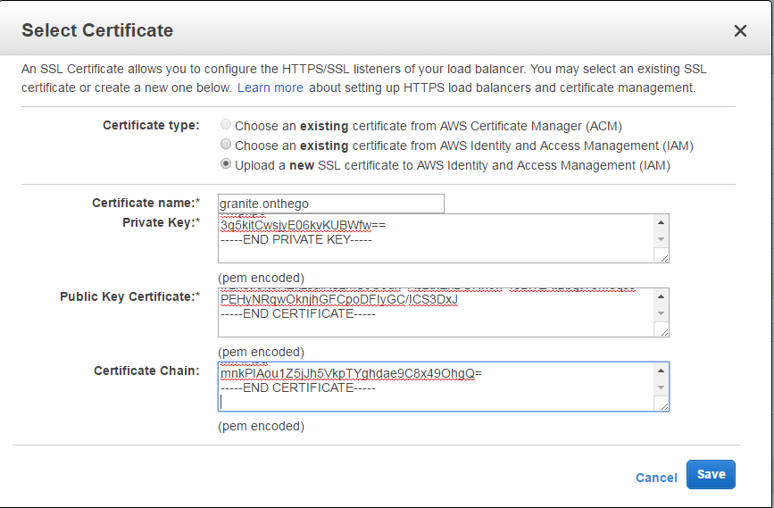
5. Click Save to upload the new certificate to the ELB.

# For reference, also see: **Create a Classic Load Balancer with an HTTPS Listener**

<http://docs.aws.amazon.com/elasticloadbalancing/latest/classic/elb-create-https-ssl-load-balancer.html#create-https-lb-console>

|  |  |
| --- | --- |
|  |  |
| Tuesday, December 20, 2016 | |
| Border, Shaun (GE Power) |  |
| hey | 11:32 AM |
| what is the i3 elb name for this app | 11:32 AM |
|  | |
| Taylor III, Donald (GE Power) |  |
| one sec, looking... | 11:32 AM |
| PROD is i3-p-fs-onthego-157939612-1791429233.us-east-1.elb.amazonaws.com | 11:33 AM |
| we don't do CSC certs for STG, right? | 11:33 AM |
|  | |
| Border, Shaun (GE Power) |  |
| yu can | 11:34 AM |
| but not usually | 11:34 AM |
|  | |
| Taylor III, Donald (GE Power) |  |
| ok, good, i'm not going to unless they want them for some reason | 11:35 AM |
|  | |
| Border, Shaun (GE Power) |  |
| whcihapp is this | 11:37 AM |
| granite | 11:38 AM |
| looks like I got apm setup | 12:16 PM |
| I have not tested the URL but it took the certs | 12:16 PM |
| is that working for you? | 1:07 PM |
|  | |
| Taylor III, Donald (GE Power) |  |
| i'll try it now | 1:07 PM |
| the content is messed up but it looks like the URL and certs are working | 1:09 PM |
| i'll tell the project team | 1:09 PM |
| thanks! | 1:10 PM |
|  | |
| Border, Shaun (GE Power) |  |
| sweet | 1:10 PM |
| not sure what the issue was | 1:10 PM |
| I just pulled the key from artifacotry | 1:10 PM |
| also noticed my help guide | 1:10 PM |
| has one mistake in teh I3 setup | 1:10 PM |
| it has to be https 443 to http 443 | 1:10 PM |
| where you add teh cert | 1:10 PM |
| my screen shot showed HTTPS 443 to https 443 | 1:10 PM |
| but that should not impact the cert adding just traffic flow | 1:11 PM |
|  | |
| Taylor III, Donald (GE Power) |  |
| right, i don't think that contributed to my permission error | 1:11 PM |
| how do i fix that permission issue? | 1:15 PM |
|  | |
| Border, Shaun (GE Power) |  |
| did you use cloud arch role? | 1:15 PM |
|  | |
| Taylor III, Donald (GE Power) |  |
| I logging in as Account: pnw-prod (988201728534) | 1:16 PM |
| hq/bu-pw-cldarch | 1:17 PM |
|  | |
| Border, Shaun (GE Power) |  |
| well then | 1:17 PM |
| what name did you give to the cert? | 1:17 PM |
| that first column? | 1:17 PM |
| before yu put private key in | 1:17 PM |
|  | |
| Taylor III, Donald (GE Power) |  |
| i'll have to look, when i tried it was for the granite onthego | 1:18 PM |
|  | |
| Border, Shaun (GE Power) |  |
| but this is for ASB | 1:18 PM |
| or something | 1:18 PM |
| not granite | 1:19 PM |
|  | |
| Taylor III, Donald (GE Power) |  |
| i didn't try apm since it didn't work for me | 1:19 PM |
| apm | 1:19 PM |
|  | |
| Border, Shaun (GE Power) |  |
| you may of had an issue with reusing an exsting name | 1:19 PM |
| and you don't have privs to overwrite another cert | 1:19 PM |
| see aws takes the certs and puts them in a store | 1:19 PM |
| so if there is a duplicate it would overwrite | 1:19 PM |
| and we dont' want that | 1:19 PM |
| I did the apm one | 1:19 PM |
| right? | 1:19 PM |
| that is the certs you sent me in email | 1:19 PM |
|  | |
| Taylor III, Donald (GE Power) |  |
| yes | 1:19 PM |
| apm is correctd | 1:20 PM |
| correct | 1:20 PM |
| two weeks ago (or whatever) i tried to do granite myself but couldn't get past the issue and had to have someone else do it (Raju?) | 1:21 PM |
| so i didn't even try apm this time, figuring i would run into the same issue and just waste time | 1:21 PM |
|  | |
| Border, Shaun (GE Power) |  |
| no big you just wated my time. . but I like your approach | 1:22 PM |
|  | |
| Taylor III, Donald (GE Power) |  |
| just trying to be efficient | 1:22 PM |
|  | |
| Border, Shaun (GE Power) |  |
| haha | 1:23 PM |
| I know what yu are talkinga but but didn't happen to me this time | 1:23 PM |
| so i assume it was a naming conflict | 1:23 PM |
|  | |
| Taylor III, Donald (GE Power) |  |
| that could be | 1:23 PM |
|  | |
|  |  |

**S3 MICROSITE WITH IAM PROFILE – WITH ACCESS FROM EC2 APP INSTANCE**

Create S3 bucket in AWS console – Note that STG are created in **pnw-prod**

Use either folder **stg-pw-central** or **st-pw-central-us1p**

For example, for dp-product-book, the path is: **/stg-pw-central**/**dp**/**dp-product-book**

The profile is created in GitHub by forking from **power-cloud/iam-cf-templates** and creating a new **stg-dp-product-book-iam-profile.ym**l file:

<https://github.build.ge.com/power-cloud/cf-templates>

Select the ‘Fork’ button: 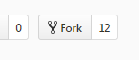

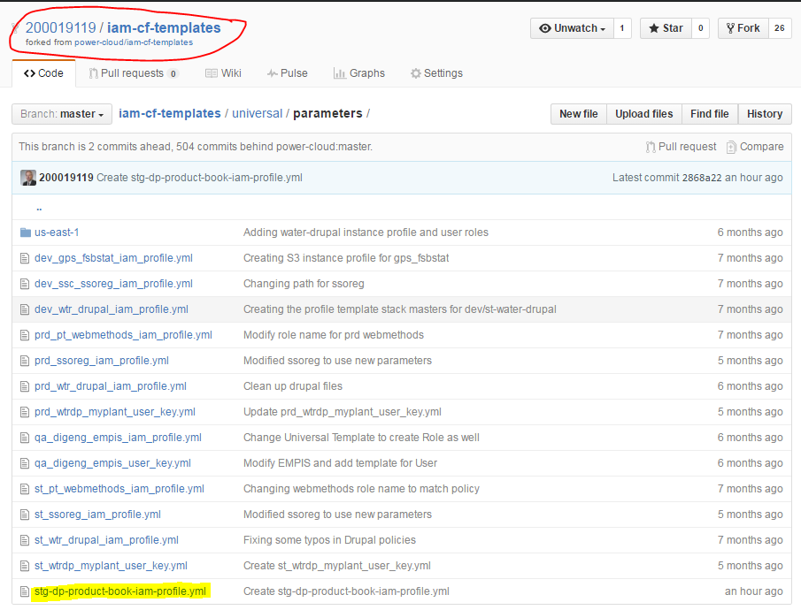

[**iam-cf-templates**](https://github.build.ge.com/200019119/iam-cf-templates)/[universal](https://github.build.ge.com/200019119/iam-cf-templates/tree/master/universal)/[parameters](https://github.build.ge.com/200019119/iam-cf-templates/tree/master/universal/parameters)/**stg-dp-product-book-iam-profile.yml**

App: dp-product-book

Environment: stg

UAI: UAI2005656

VBucketName: stg-pw-central

VBusiness: dp

VBucketPath: dp-product-book

VS3Permissions: "s3:GetObject,s3:DeleteObject,s3:PutObject"

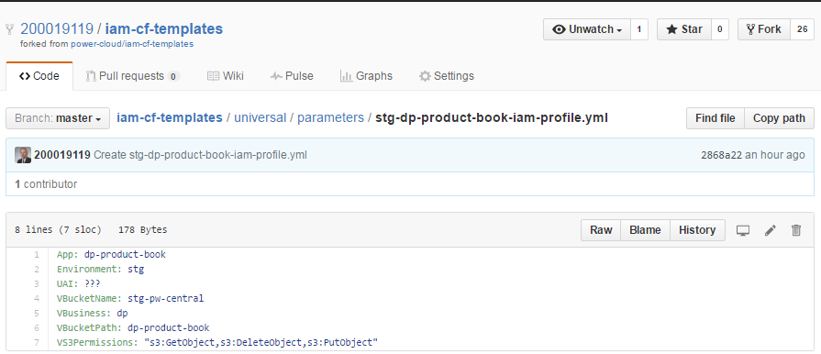

stacks:

us-east-1:

stg-dp-product-book-iam-profile:

template: universal-s3-instance-profile.json

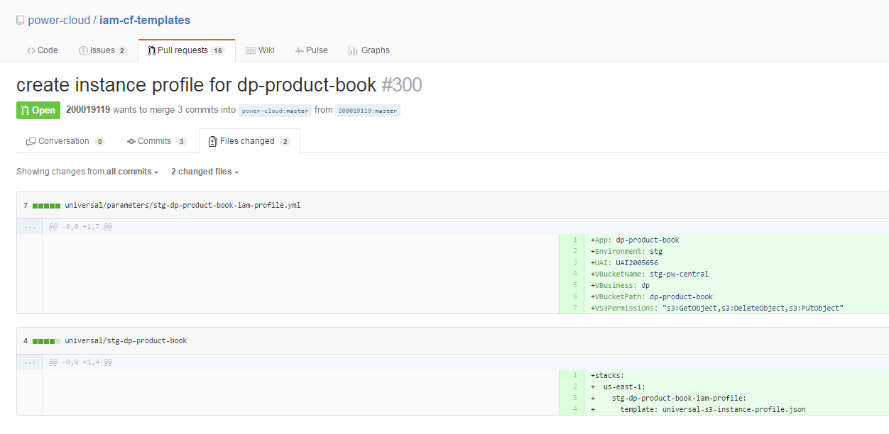

In GitHub, click the “CAT” symbol 🡪 iam-cf-templates:

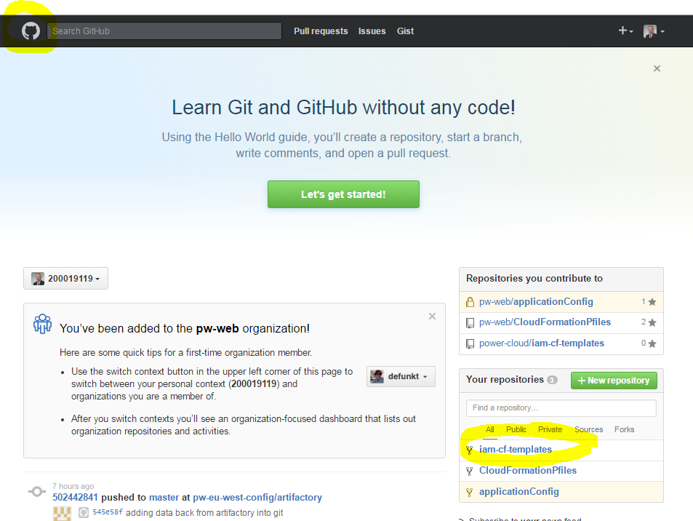

🡪 Universal

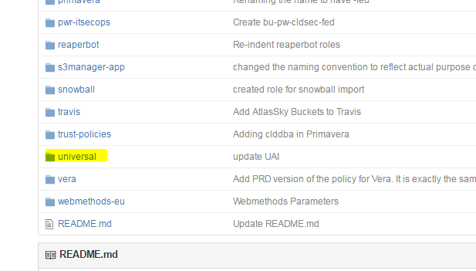

🡪 Pull Request

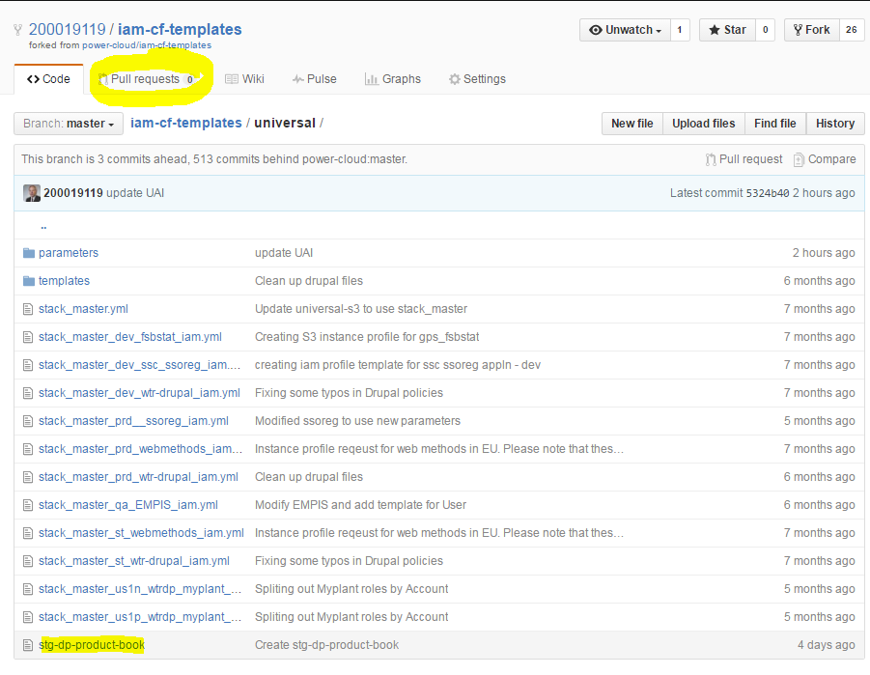

Send an email to Nik and Karthik:

“I need an instance profile created for **dp-product-book**.  This is using the S3 universal instance profile script.  I have created the STG stack master and parameter files in this pull request.”

<https://github.build.ge.com/power-cloud/iam-cf-templates/pull/300>

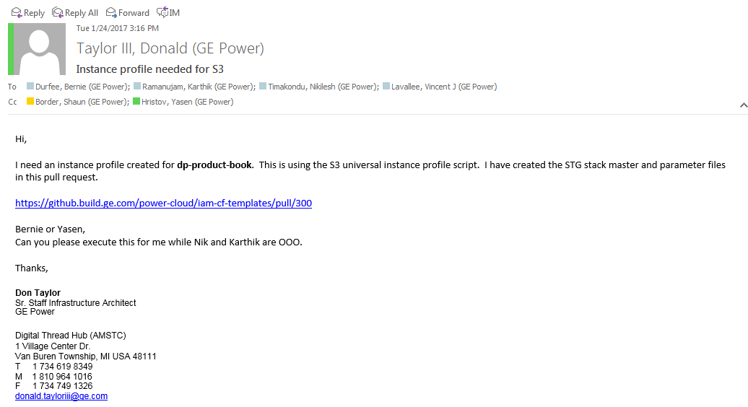

**NOTES FROM WORKING WITH SANJEEVI TO CREATE S3 MICROSITE AND INSTANCE PROFILE FOR CLEAR-ORBIT QA:**

App: clear-orbit

Environment: qa

UAI: UAI1006430

VBucketName: qa-pw-central

VBusiness: ssc

VBucketPath: clearorbit*

VS3Permissions: "s3:GetObject,s3:PutObject,s3:DeleteObject"

<https://github.build.ge.com/power-cloud/iam-cf-templates/pull/688>

stacks:

  us-east-1:

    qa-ssc-clearorbit-iam-profile:

      template: universal-s3-instance-profile.json

stack_master_us1n_qa_ssc_clearorbit_iam.yml

<https://github.build.ge.com/power-cloud/iam-cf-templates/pull/689>

power-cloud/iam-cf-templates

Role:

bu-pwr-ssc-clearorbit-qa

Request IAM role

Name: bu-pwr-ssc-clearorbit-qa

Purpose: S3 access for qa-pw-central/ssc/clearorbit

Account: us1n

Audience: n/a

<https://github.build.ge.com/power-cloud/iam-cf-templates/issues/690>

Issue request

<https://github.build.ge.com/power-cloud/iam-cf-templates/pull/690>

ping JP - submitted iam profile request and my issue ticket is 690

<https://github.build.ge.com/power-cloud/iam-cf-templates/pull/690>

two pull requests 68 & 69 (ref in issue ticket)

<https://github.build.ge.com/power-cloud/iam-cf-templates/pull/688>

<https://github.build.ge.com/power-cloud/iam-cf-templates/pull/689>

std iam profile request using universal stack master

|  |  |
| --- | --- |
| Moutouvel, Sanjeevi (GE Digital) |  |
| IAM Roles: <https://devcloud.swcoe.ge.com/devspace/display/LDLUN/Process+-+IAM+Roles+-+Request+and+Change> | 10:12 AM |
| <https://github.build.ge.com/power-cloud/iam-cf-templates> | 4:12 PM |
| Name of the role (which may get adjusted by us to meet the naming conventions) bu-pwr-prd-gepower-com-app bu-pwr-stg-gepower-com-app Whats the purpose and scope (what services and the required privileges) ! Update stage bucket - st-pw-central-us1p/pw-hq/gepower/* Which Account(s) (VPC) US1P (for PROD and STG Stackmaster file) The audience/members using that role in case its a federated role (mostly console access) Not Applicable |  |

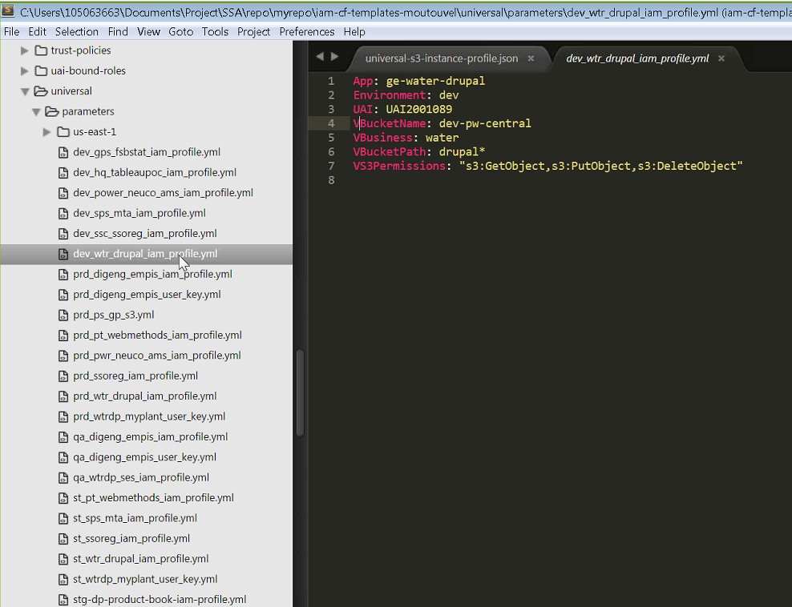

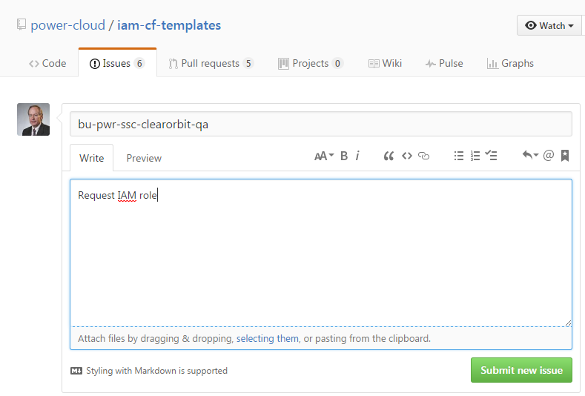

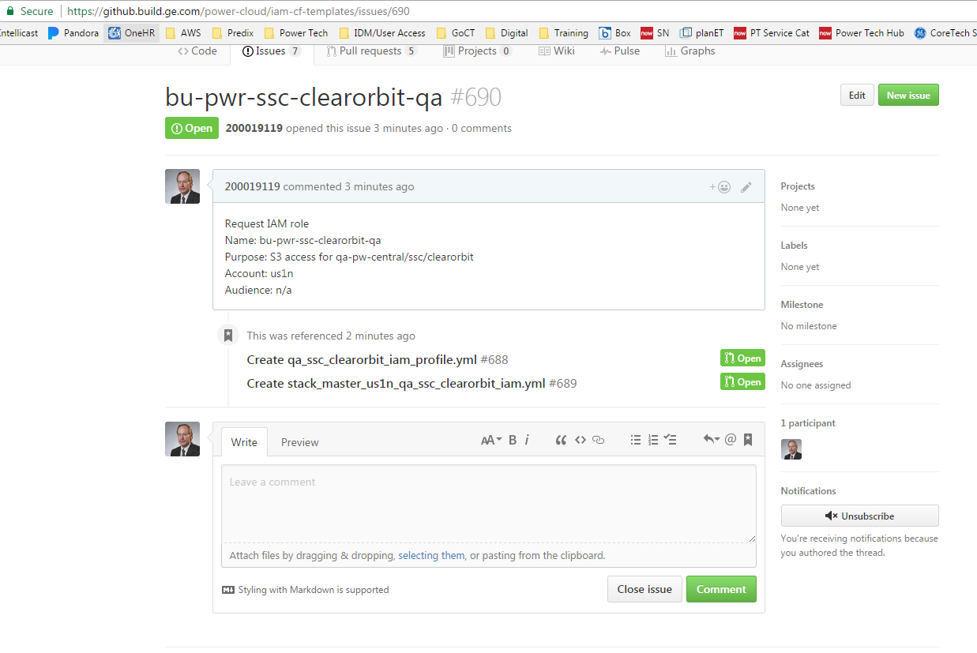

**PUBLICALLY ACCESSIBLE S3 MICROSITE**

View from CF Gen/Microsites

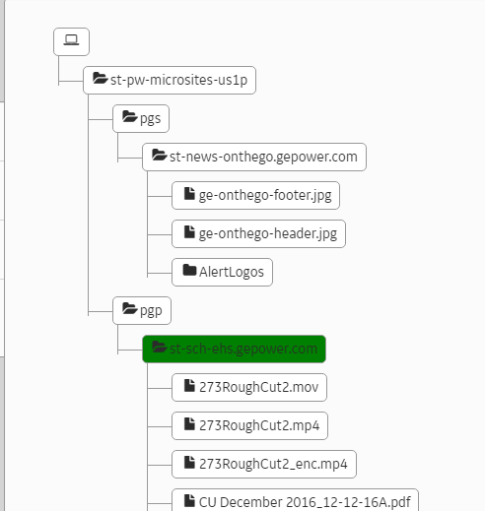

View from AWS **pnw-prod** console:

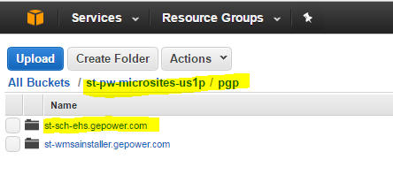

To view the contents of PROD (via Sync to PROD), in the AWS console 🡪 S3 🡪 navigate to the folder path:

<https://console.aws.amazon.com/s3/home?region=us-east-1#&bucket=pw-microsites-us1p&prefix=pgp/sch-ehs.gepower.com/>

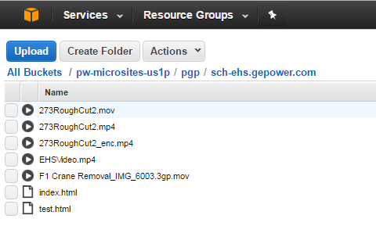

S3 logs are at: pw-microsites-logs 🡪 project S3 bucket

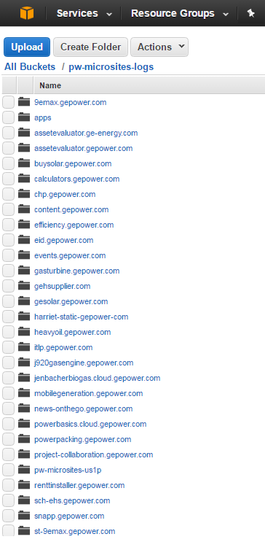

**Example of URL that is created to view content:**

<http://st-sch-ehs.gepower.com/CU%20December%202016_12-12-16A.pdf>

Note that ‘%20’ is used for spaces in the URL

**ADDING INSTANCE PROFILE TO STACK BUILD**

AWS Console 🡪 IAM 🡪 Roles 🡪 Role Name 🡪 Instance Profile ARN

For example (empis):

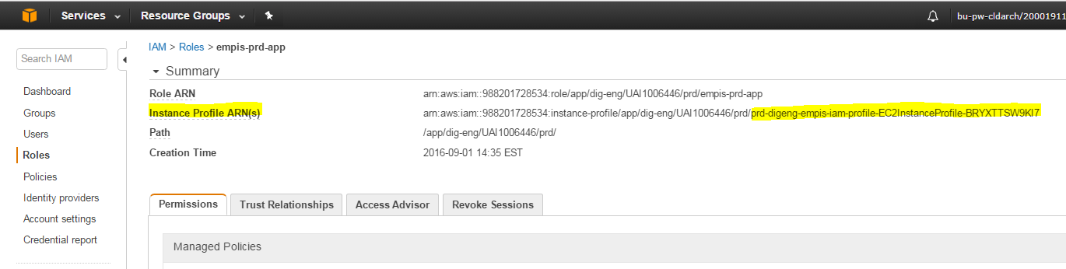

Enter the InstanceProfile for EC2. Go to IAM --> Roles --> Search for Role Name --> Look for Instance Profile ARN(s). Fetch the string after last slash (/)

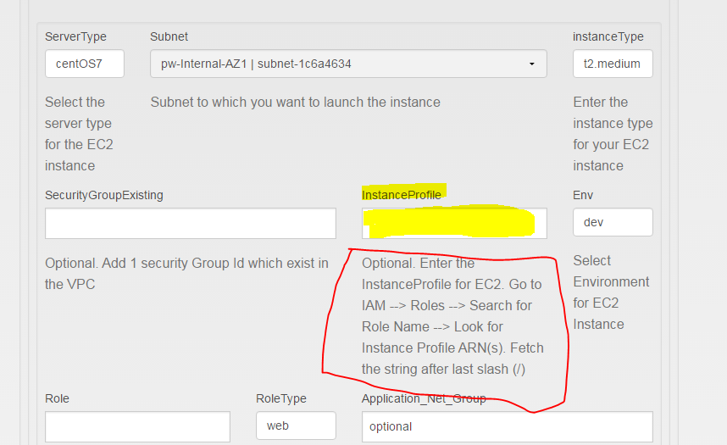

|  |  |
| --- | --- |
| Adding S3 Instance Profile after the EC2 app instance is created:  From the console - Actions - Settings - Change/replace IAM role  Screen capture |  |

**AUTO DEPLOYMENT**

Hi Naseer,

            A while back you helped us set up the auto-deployment for the Dev environment for our app PO-SURVEILANCE(MSP), what do we need for the setup for the Prod environment deployment?

<https://jenkins.pw.ge.com/jenkins/view/po-surveilance/>

**Jorge Vidrio**

You can follow same process. However while publishing choose [po-surveilance-prd](https://github.build.ge.com/pw-web/applicationConfig/tree/master/po-surveilance/po-surveilance-prd) as app instance name and your code will be deployed to production

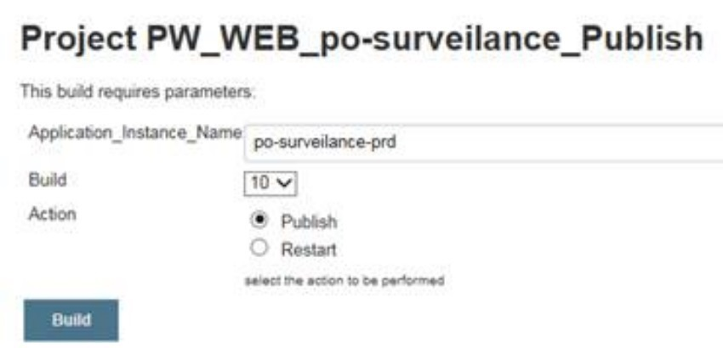  
Naseer Sayyad

PHP Code Deployment and Auto-deployment (from MyQMS)

 --from Naseer Sayyad (to Edgar)

1.       Add pw_web_jenkins as a developer to the repo.

2.       Provide your group DL to provide access (Ensure Web SSO is set to enabled in idm)

3.       Provide a target (folder) to which the code needs to be deployed on your ec2 instance.

The path of the target folder will be the following one: /opt/software/MyQMS/www/

--from Raja (Yedukondala Rajavarapu)

We have completed the QA deployment using automation and used Jenkins to deploy code. And now, the QA Jenkins jobs migrated to PROD Jenkins.

Below is the new URL to deploy code for your all environments, please do not use QA Jenkins URL going forward.

<https://jenkins.pw.ge.com/jenkins/view/pex/>

Note:

If you modified any changes in code and once done with your changes check in updated code to this repo and in Jenkins click on build job go to build with parameters and say “build”.

If you see it is successful, open publish job same click on build with parameters and select instance name in dropdown list and click on build.

Once publish job also successful check in server whether the files deployed or not, in case if you have any issues please reach us over jabber we will help you.

The deployments to ec2 instances are not based on IPs. As long as the application instance name (the instance name that you chose in publish job) assigned to your new instances is same as old, there is no change required.  
Naseer Sayyad   
Cloud Automation Engineer

**Force chef to run on AWS Instance**

[from Gabe]

There is a Jenkins job we can run now to force Chef to run on AWS Instances: <https://jenkins.pw.ge.com/jenkins/job/execute_chef/>

To use it, you just need the instance IP and it should work across VPCs. A caveat: If there is an issue with the Chef client on the instance, this will not resolve it and you will have to work with the Automation team to fix that. An example of where this can be used is when you are setting up SA access to an environment you are about to jump in to support and you don't want to wait up to 30 minutes for the access change to propagate. I have added the link to the last step of the process for SAs to get access to Linux instances here: <https://devcloud.swcoe.ge.com/devspace/display/SGYXB/Server+Access+In+AWS>

**PWT TEAM CONTACTS**

**For design questions** please contact @POWER & WATER Enterprise Cloud Architecture <[pw.cloud.architecture@ge.com](mailto:pw.cloud.architecture@ge.com)> or the SA for your P&L

**For support** with applications in AWS please create a ticket to

•              AWS support - @POWER Enterprise Cloud Ops <[pwenterprisecloudops@ge.com](mailto:pwenterprisecloudops@ge.com)>

•              Web support - @POWER AWS Web Support <[pw.aws.webspt@ge.com](mailto:pw.aws.webspt@ge.com)>

•              i3/NAT/Corp support - @CORP IT Cloud Day2ops <[devopsday2ops@ge.com](mailto:devopsday2ops@ge.com)>

**CF Gen**

[Vishal.Maheswari@ge.com](mailto:Vishal.Maheswari@ge.com)

**Build Factory**

[vatsan.varadharajan@ge.com](mailto:vatsan.varadharajan@ge.com)

[Mustafa.Fatakdawala@ge.com](mailto:Mustafa.Fatakdawala@ge.com)

[saleem.rafiq@ge.com](mailto:saleem.rafiq@ge.com)

**Web Ops**

[naseer.sayyad@ge.com](mailto:naseer.sayyad@ge.com)

[Raju.Swargam@ge.com](mailto:Raju.Swargam@ge.com)

[Swaroop.Kishan@ge.com](mailto:Swaroop.Kishan@ge.com)

[Ramesh.Yv@ge.com](mailto:Ramesh.Yv@ge.com)

**Web & B2B** – Ken Goodman

**Database** – Brian Millard

**Cloud Ops**

[trijit.acharyyachowdhury@ge.com](mailto:trijit.acharyyachowdhury@ge.com)

**Auto Deployment, CI/CD & Jenkins**

[yedukondala.rajavarapu@ge.com](mailto:yedukondala.rajavarapu@ge.com)

[naseer.sayyad@ge.com](mailto:naseer.sayyad@ge.com)

[venu.tadepalli@ge.com](mailto:venu.tadepalli@ge.com)

**Cloud Integration**

Informatica - owner Ignacio Diazmacip (204057525)

NEW Informatica SERVERS - owner Ignacio Diazmacip (204057525)

Talend PWT - owner Ignacio Diazmacip (204057525)

Talend PWT - owner Ignacio Diazmacip (204057525) - NEW Enterprise Servers

Talend PG - owner Ajay Chaubey (307002560)

WebMethods OnPrem - owner @POWER & WATER webMethods Operations [pw.webmethodsops@ge.com](mailto:pw.webmethodsops@ge.com)

Mediator - owner Ramesh Kuruba (212069299)

Akana – Marton Berta (502295073)

Tableau - owner Jorge Martinez (204057520)

Real-time integrations (WebMethods): Kuruba, Ramesh (GE Power) <[Ramesh.Kuruba@ge.com](mailto:Ramesh.Kuruba@ge.com)>

Batch integrations (ETL, like Informatica and Talend): Tyler, Jeff (GE Power) <[jeff.tyler@ge.com](mailto:jeff.tyler@ge.com)>

Informatica team – @Power & Water ETS Infomatica Ops

Contacts :

• Shankar, Ravi1 (GE Power, Non-GE) ravi.shankar5@ge.com

• Diazmacip, Ignacio (GE Power) <Ignacio.Diazmacip@ge.com>

Ignacio is the point of contact for Talend integration too

Web Methods - @POWER Integrations Development Factory <Integrations.DevelopmentFactory@ge.com>

**Setting up GitHub access:**

There are a couple of things I would suggest:

1. <https://github.build.ge.com/>: This is a GE specific github deployment. All our AWS servers have access to this service.
2. We do not recommend ge code on our production servers and expect a Continuous Integration (CI) and Continuous Delivery (CD)  pipeline code to handle the code quality checks, code packaging and delivery to the servers. We can help you set-up a dedicated or shared Jenkins server which will have the jobs to check-our, test, package and deliver the code to your respective servers.

I just verified and found out that my earlier statement about github access is incorrect. Github is accessible only in the integration subnet and from your server: 10-229-236-20. It is not accessible. You will be able to use our ci-cd tools to build and deploy to this server.

**Venu Tadepalli**, Cloud Platforms and Automation

So, no way to have the app instance to access GE Git.

Venu, can you please let us know more about “We can help you set-up a dedicated or shared Jenkins server which will have the jobs to check-our, test, package and deliver the code to your respective servers”:

* Can you provide an existing shared Jenkins server to do that or are you requesting for each website/application a specific Jenkins server or a Jenkins server for many applications but one per vendor…?
* Any GE document about what’s must be follow on this topic is welcome (Octopoos team already know Jenkins technology)

Since your team knows Jenkins, we can set-up a separate Jenkins server for you from where you can managed all you builds and deployments. In order to set-up this server we will need a UAI and DL for the users who will access the Jenkins and Naseer will be able to provide you the brand new Jenkins.

 The other option is a shared environment, where we can set up an individual job for you and manage it there. If you want this option, Naseer can provide you the spreadsheet with the details he requires for adding your job to the shared Jenkins.

 I think option 1 is preferable, since it gives you more control over your builds and plugins and you are not impacted by other apps building in a shared infrastructure.

 Venu

Is there please some business cost to get this Jenkins server?

Yes, there is a cost. We use t2.medium instance. But if you don’t want to have it up all the time to perform on commit builds or pull request processing, you can stop the server to minimize costs.

Right now, there is no cost involved in using shared Jenkins.

**IAM**

Unfortunately, AWS does not allow us to add IAM profiles to an existing server. Instead it can only be attached during server creation. Therefore, we will need to create a new server for this, and attach the IAM profile to it. The same had to be done for the QA server as well.

If nothing is setup on the server, then we recommend creating a fresh server. Otherwise, we will need to try to replicate the current server.

**Vatsan**

Resizing an EC2 Instance and adding disk capacity (from FS-onthego)

*Please make this resource upgrade on production application with IP 10.229.236.20:*

* *c4.xlarge (4 vCPU/7.5GiB Mem) reserved*
* *add 50GB General Purpose SSD (gp2)*

*Sebastien Lapoux*

1. Instance must be stopped before it can be resized (Instance Settings 🡪 Change Instance Type)
2. Turn on Termination Protection first (Instance Settings 🡪 Change Termination Protection)
3. For instances older than 30 days, these changes should be made by the Cloud Ops Team (Andy Pfister) via an RITM to Power & Water Cloud Operations
4. Adding a new volume is easier than expanding an existing one (need to take a snap shot first)
5. AWS Console 🡪 EC2 Instances 🡪 Volumes 🡪 Create Volume 🡪 Attach Volume
6. NOTE: Make sure the new volume is created in the same AZ as the app instance

NOTES from Utilis-CMMS

* GitHub – pw-cloud/ucmms/hefesto/web config
* Web config – updated database string
* Update mail relay in Hefesto
* Changes need to be checked into GitHub
* Jenkins 🡪 pw-web_utiliscmms_build
* Build pulls all files from Git, puts files in Artifactory, publish to server, pw-web_utiliscmms_publish
* Select build #
* Example: domino-infra/stg-domino-infra-ext

**Class instances for app servers**

From Yasen (email), 2/22/17

I see some instances where T2 class instances are used for app servers in PRD. Please keep in mind that T2 class instances have a ‘shared’ CPU, so they are quite limited in CPU power and this can potentially cause performance issues. Please see description of the product (and specifically around the ‘burstable’ CPU feature) at <http://docs.aws.amazon.com/AWSEC2/latest/UserGuide/t2-instances.html#t2-instances-cpu-credits>. Effectively you can consider 1 vCPU in a T2 to be equivalent to only a portion of a ‘real’ vCPU in the other instance types. It is warranted to use such type only when there is no case the app would reach 100% CPU for more than say 5 minutes per 24 hours period.

We typically use t2.small for web instances (since they for the most part only shuffle traffic back and forth and don’t do much else). For application servers it is OK to use T2 for non-production. For PRD you might want to consider using an M4, C4 or R4 class.

Here is an example (in eu1p)

**Instance:  i-0e5c27d4102c4c633 (prd-dp-spatsl2-0-ser-app)Private IP: 10.222.240.180**

is of type t2.xlarge. This means 4 vCPUs x 16 GB RAM.

I assume the ‘real requirement’ here is the RAM. Consequently IMO it is better to use a r4.large

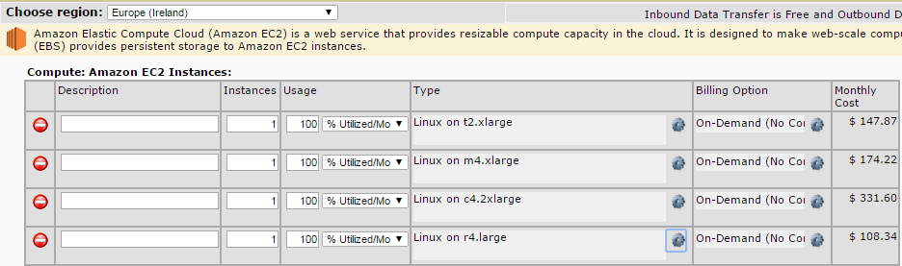

In this particular case it is more cost effective. It gives you 15.2 GB RAM + 2 ‘real’ CPU cores. In addition to this it gives you better I/O performance. There are simply fewer VMs on a physical box, therefore more bandwidth for your VM over the shared NIC.

Instance type sizes for these particular example



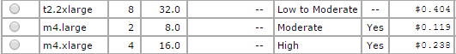





One more thing. When it comes to T2 instances you might want to look at the ‘CPU Credit Balance’ CloudWatch metric under ‘Monitoring’. If you see the credit dropping to zero, it is bad. It means your app is trying to consume more CPU that it is allowed. This should mean you see 100% CPU utilization within the CPU. In this particular instance it seems it is OK, but as I said it is probably better to move to an r4.large (2x15)

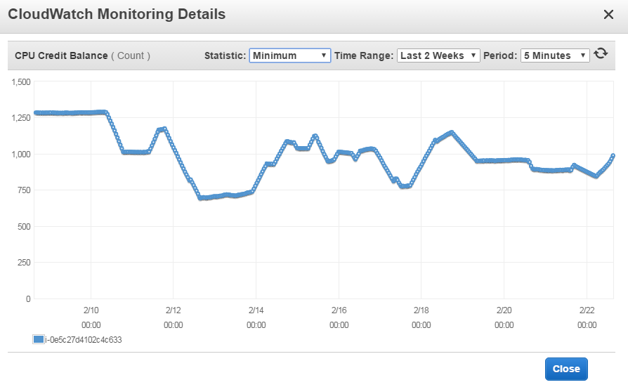

Internally facing: <*app*>.power.ge.com <stg-*app*>.power.ge.com

Externally facing: <app>.gepower.com <stg-*app*>.gepower.com

PingFederate – <https://fssfed.com>

Imperva WAF

OIDC registration now includes B2B Policy Package option (uses Corp. LDAP ~ via IDM?)

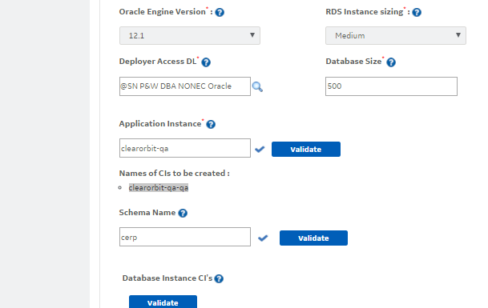 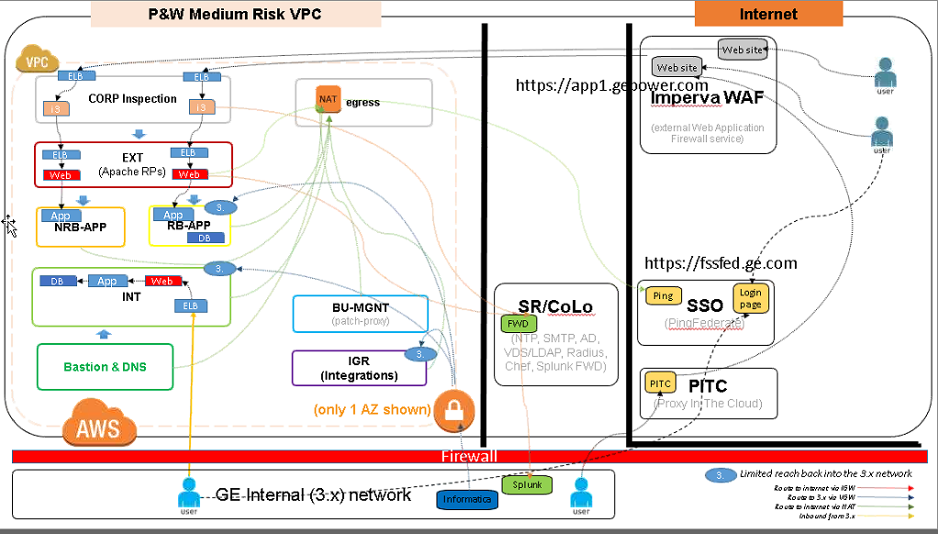

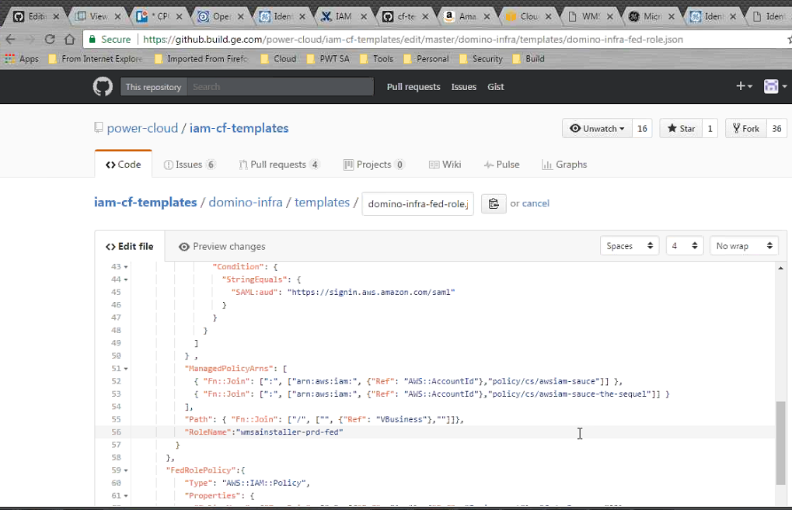

502396654 – Pankaj Kulkarni

New DL created

Display Name : @Digital WMSA Installer PublisherDistribution List ID : g01199931Email address : [WMSAInstallerPublisher@ge.com](mailto:WMSAInstallerPublisher@ge.com)

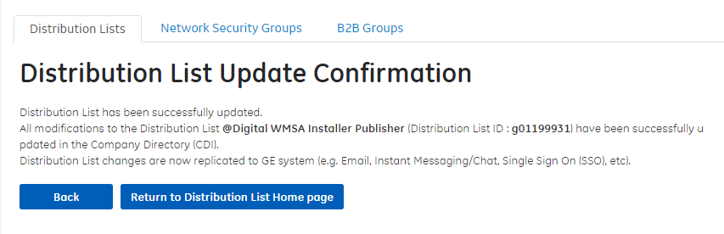

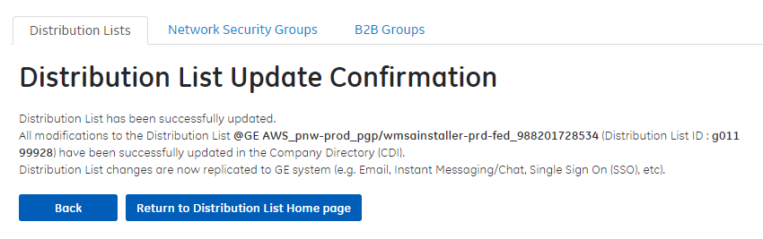

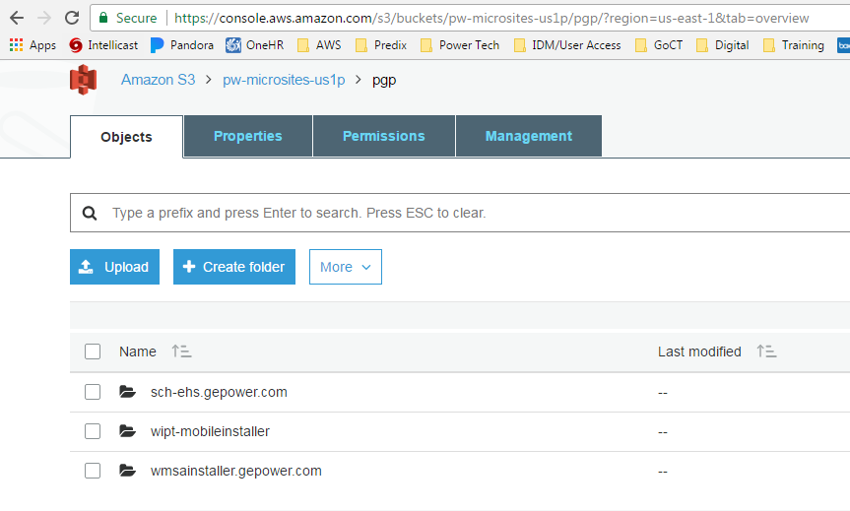

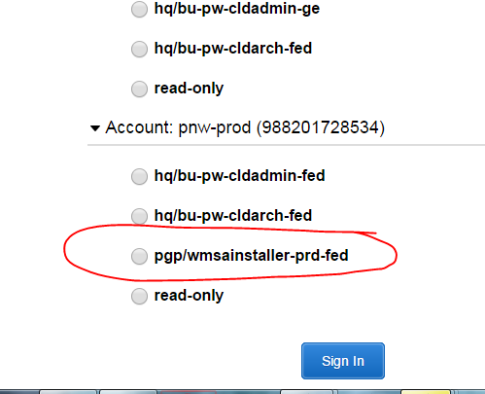

**Connecting a database tool like SQL Developer via a tunnel through the Bastion host to an RDS instance.**

These instructions are from **Charles Edwinraj, Renewable Energy (Energy Connections):**

Developers need this information when they need to connect to AWS databases from their local.

Step-by-step guide

1. Connect to VPN if you are not in GE network
2. Install Putty from App Depot if you do not have it installed already.
3. RDS instances needs to be accessed by tunneling through one of the bastion hosts.
4. Open Installed Putty  
   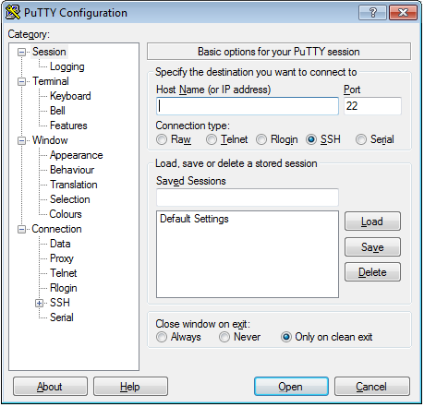
5. Go to Session
6. Enter the below host name

**Hostname /Bastian IP address**

DEV        : 10.227.255.110

STAGE   : 10.229.255.110 / 10.229.255.140

PROD    : 10.229.255.110 / 10.229.255.140

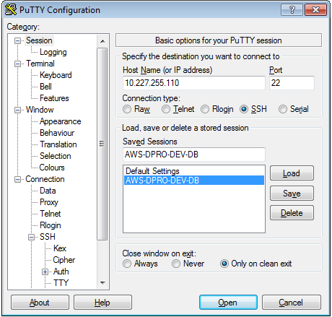

1. Enter a name for the session and Click SAVE
2. Go to SSH -> Tunnels
3. Provide the below URL's in destination

Host:port

1. Provide the below port in source port field (We can use any available port)
   * 1. For Dev : 45432
     2. For Stage : 55432
     3. For Stage : 65432
2. Go to Sessions again and choose the same name and save again
3. Goto Connection -> Data
4. Give your NIX Id in Auto login username  
   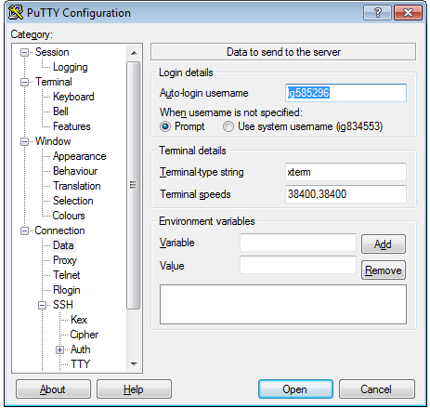
5. Again go to session and choose the saved settings and save
6. Choose the session from putty and open  
   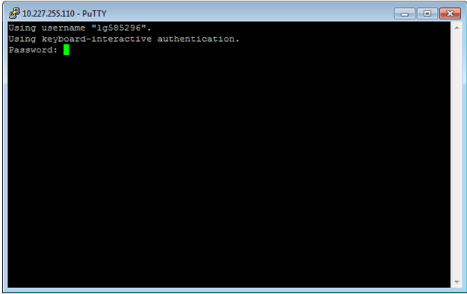
7. Provide your VPN PIN + Token  
   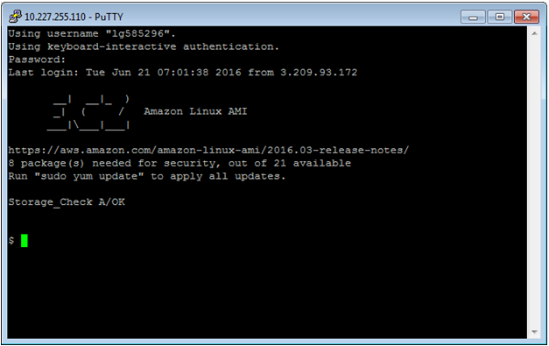
8. Open pgAdmin III
9. Add a new server  
   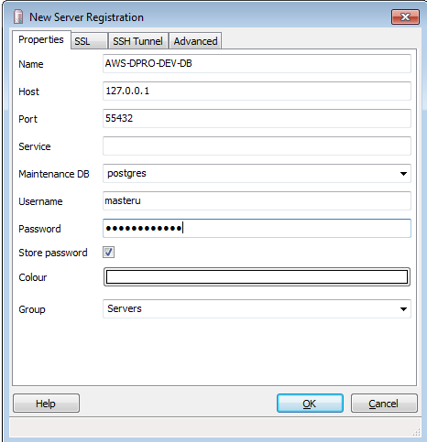
10. Now you can access the AWS database from your local